Home page

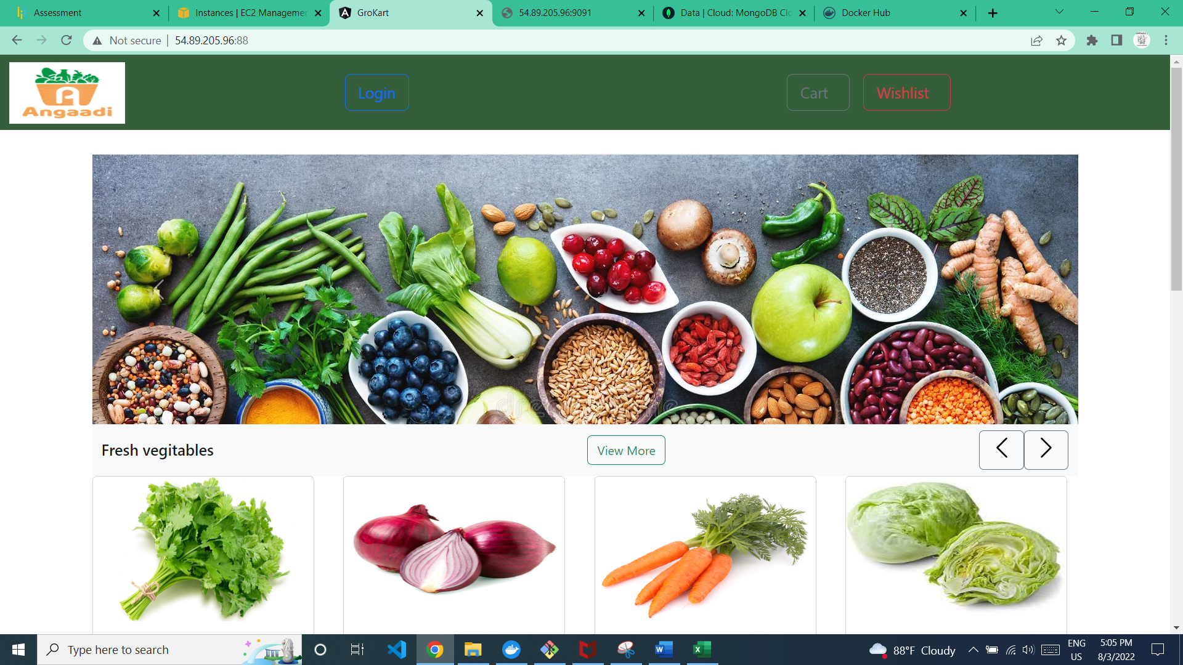

**NB: If the user doesn’t login some of the operations will be redirect to Login page. Either user should login or create a user account**

1.Header/Navbar



Navbar includes

1.Login button

2.cart button: To view added cart items(This page will be able to see once the user login the application)

3.Wishlist: To view added wishlist grocert items(This page will be able to see once the user login the application)

2.Vegetable section

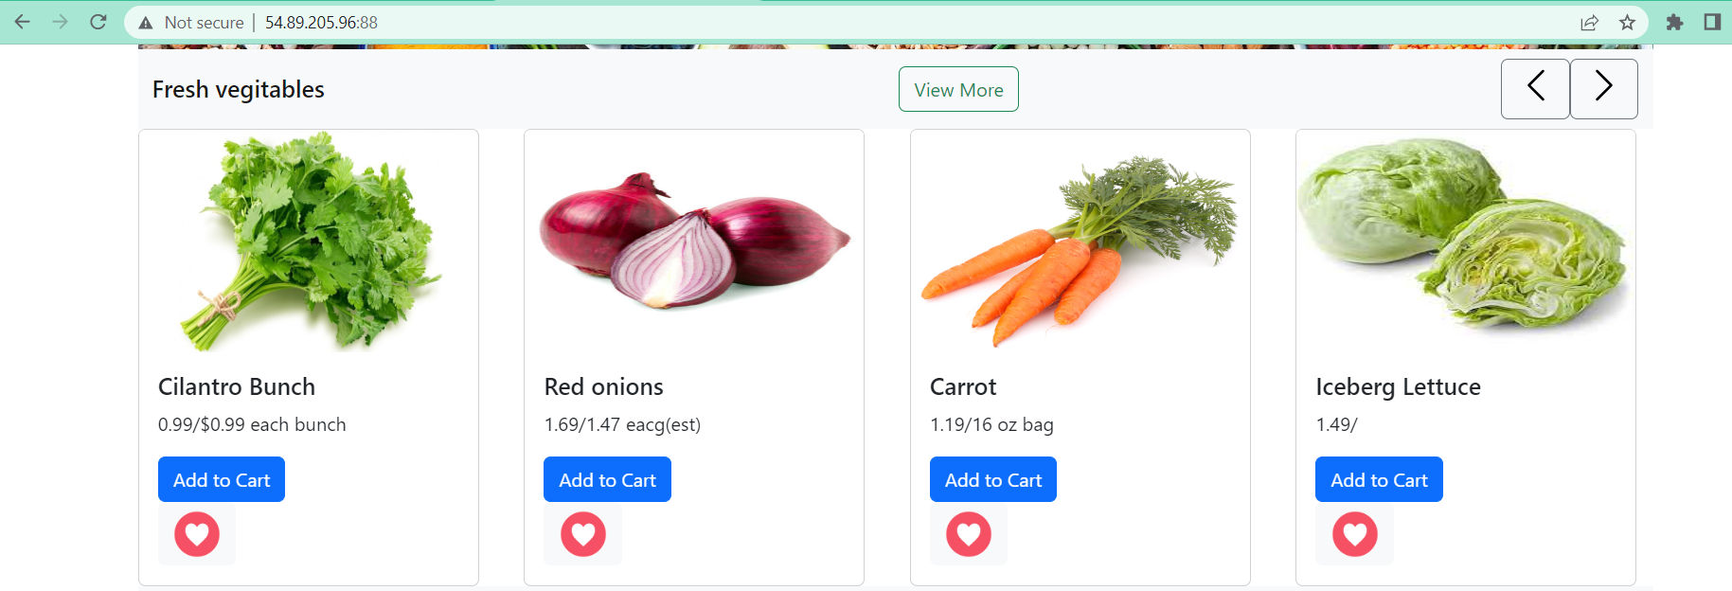

Vegetable section have

**1.sliding bar**

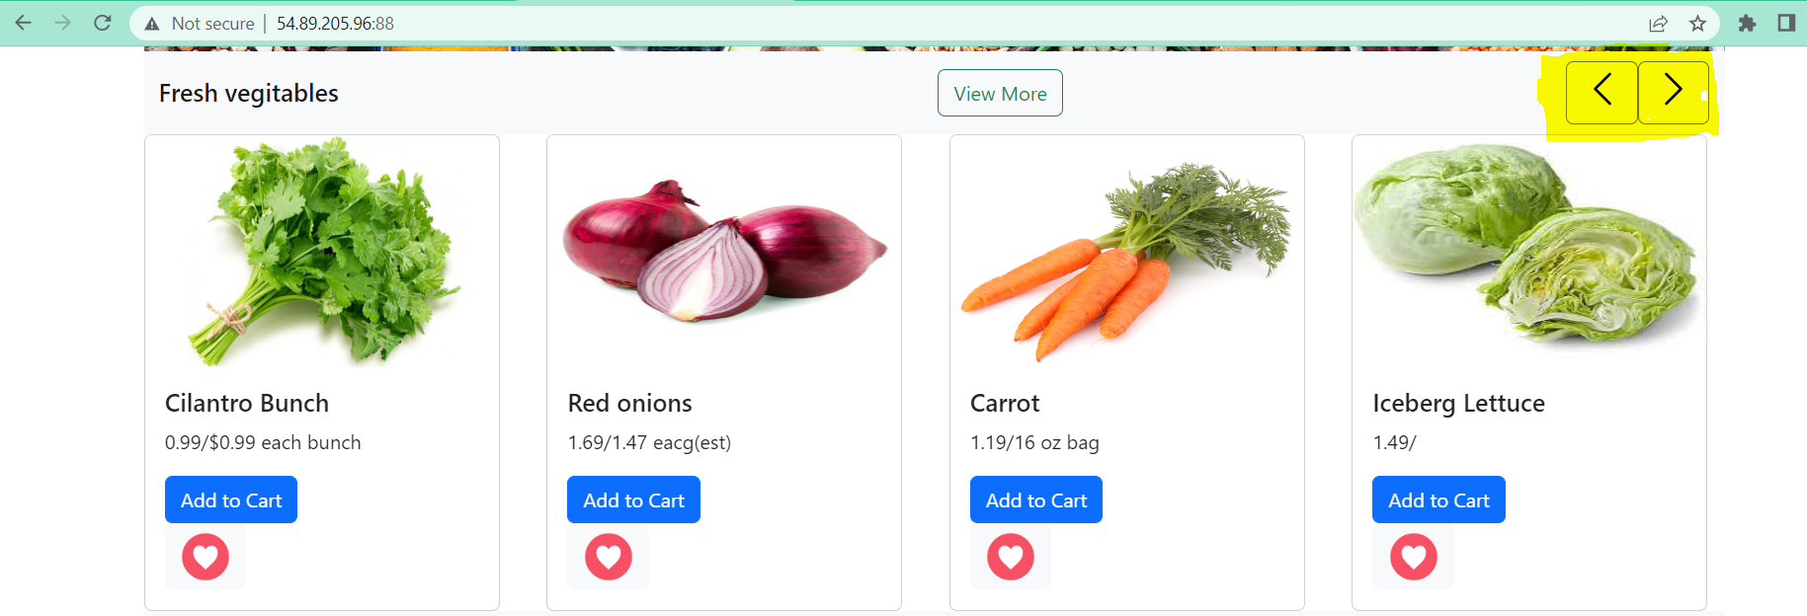

Once user clicks on the arrow buttons, user can see more vegetables if available

**2.View more button**

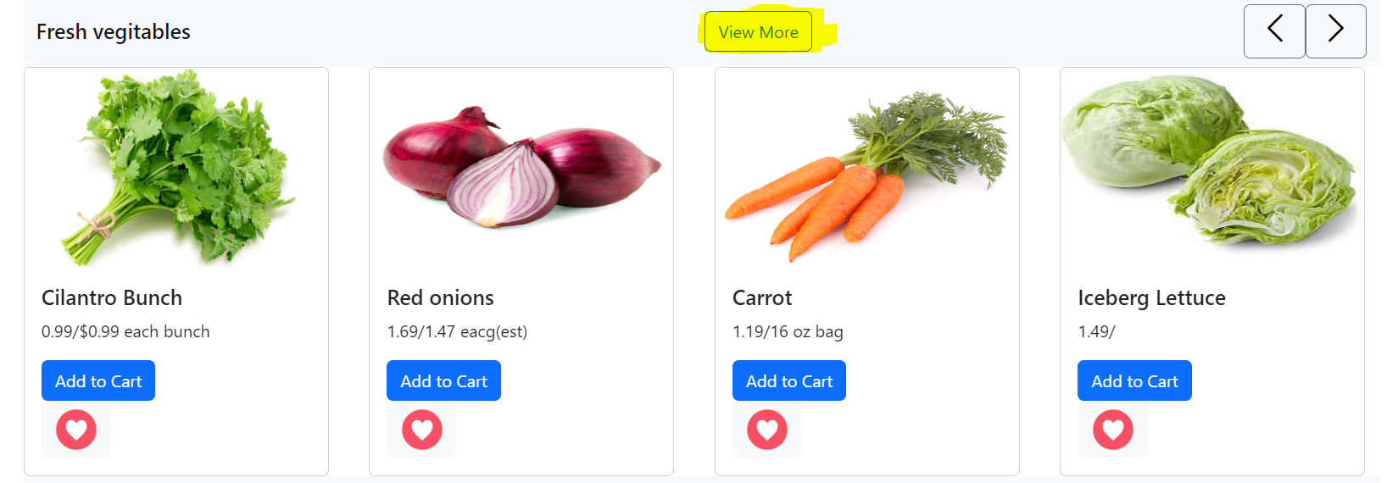

Once clicks view more button, the whole list of groceries will be available in a single page.From there user can select the vegetables and do the operations like add to cart/wishlist,…

**After clicking view more button**

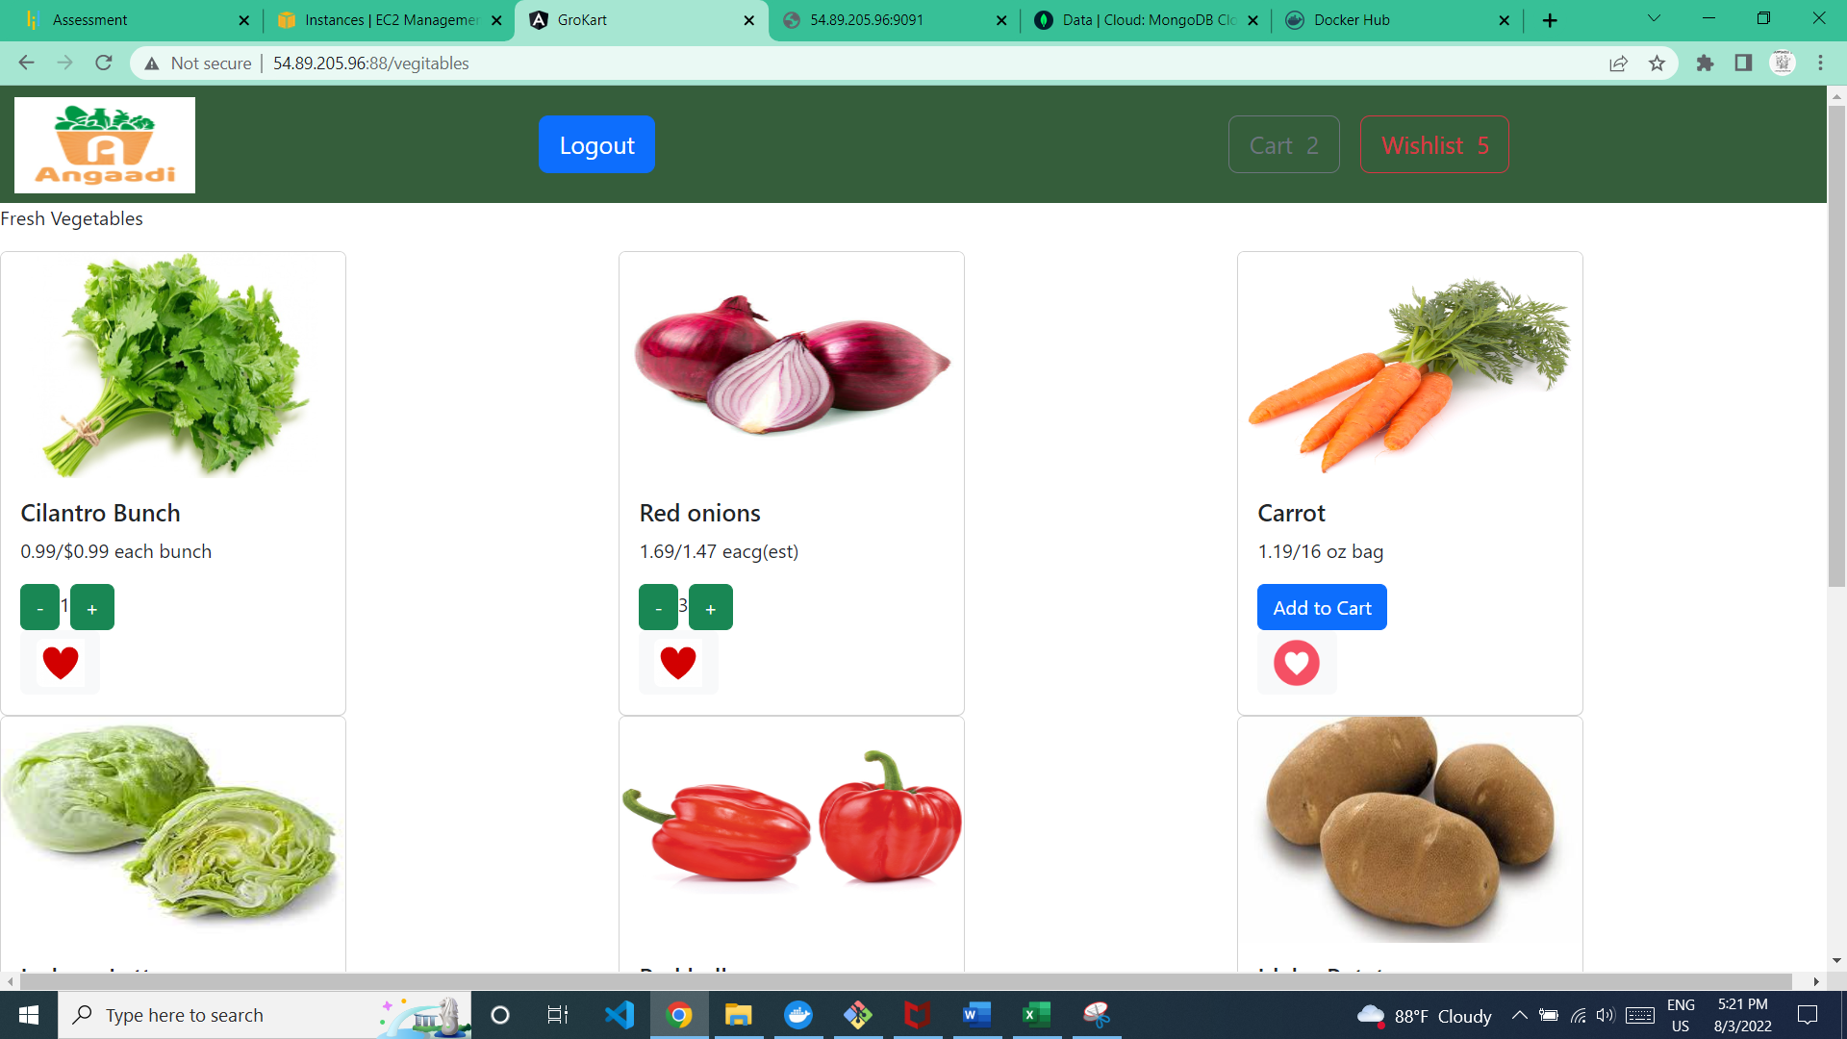

**3.Add to cart**(This operation will be able to see once the user login the application)

Before clicking add to cart

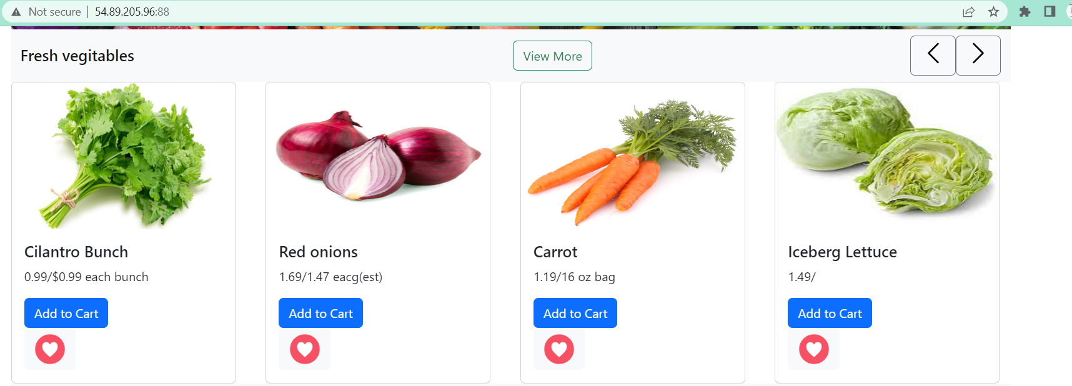

After clicking add to cart

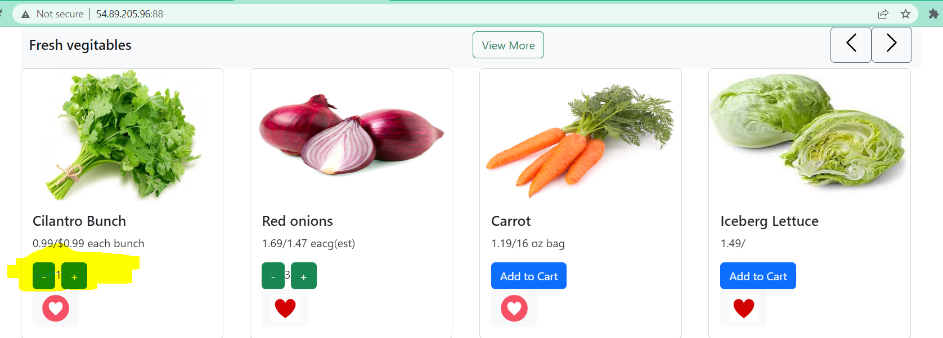

Once user clicks on the add to cart button, the vegetable will be added to the cart

Once the user added the vegetables to the cart, the button will turn into a increment/decrement button to add more quantity of vegetables

**4.Wishlist**(This page will be able to see once the user login the application)

Before adding to wishlist

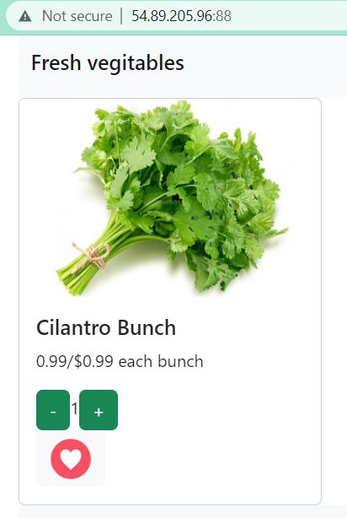

User should click on the highlighted button to add vegetables to wishlist

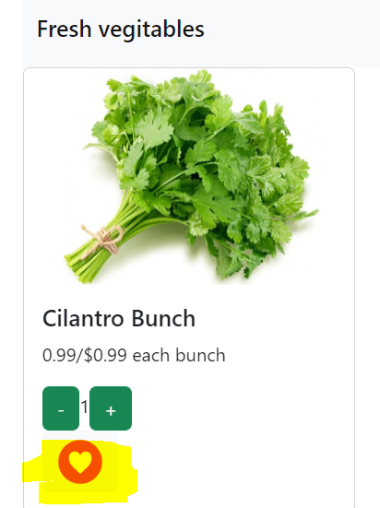

After adding vegetables to wishlist

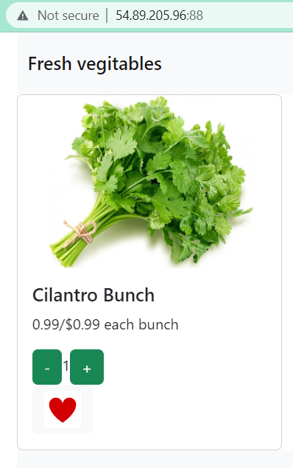

**5.Grocery Home page**(This page will be able to see once the user login the application)

Once you click on the image of each vegetable, the user will navigate to below page

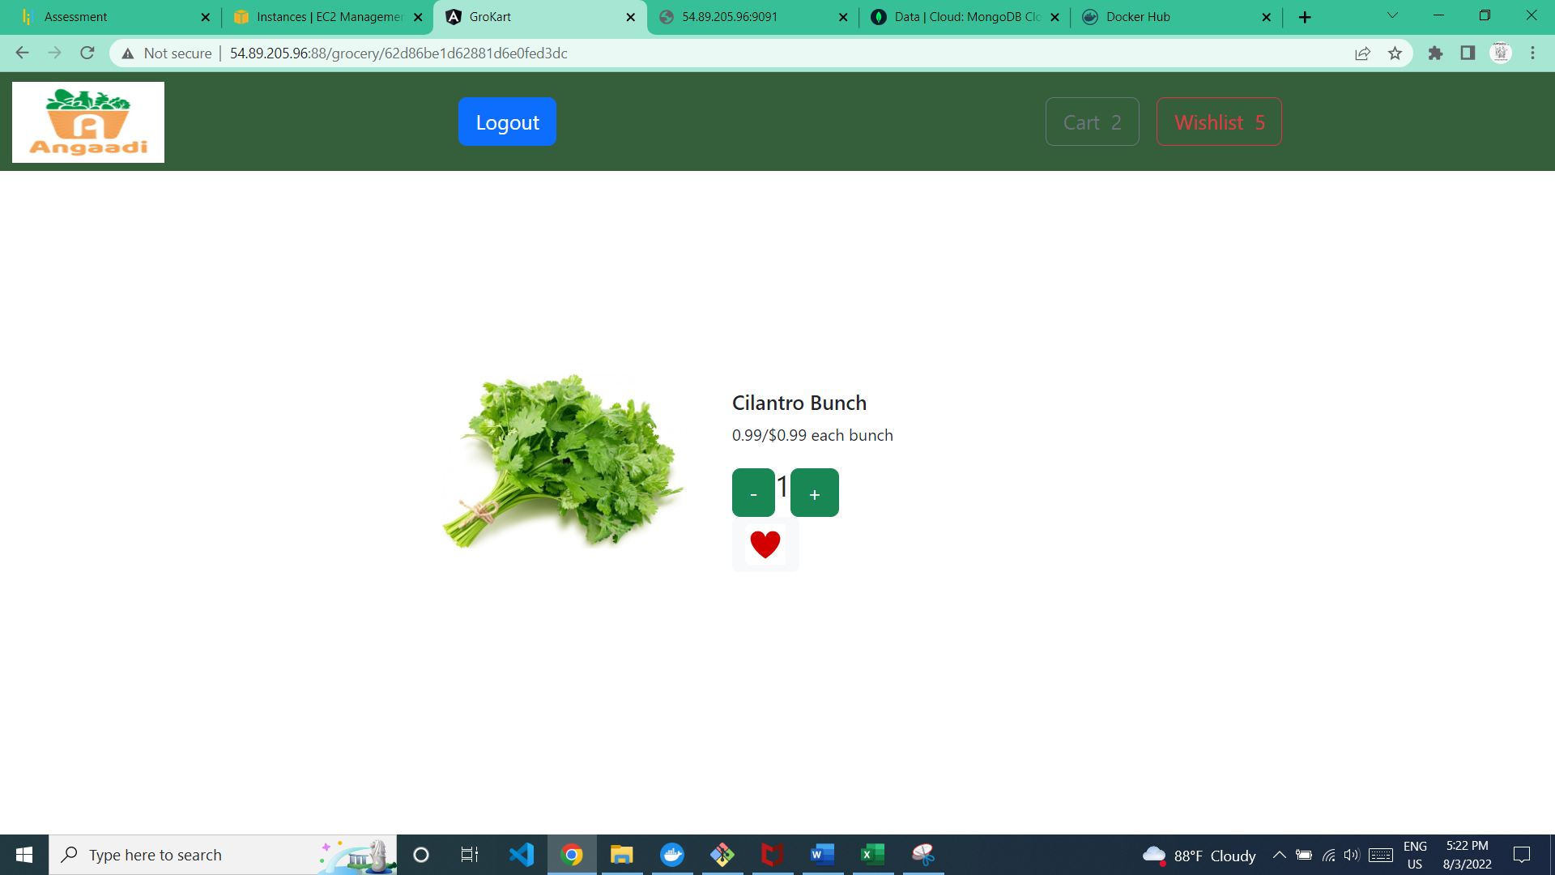

From this page also user can add the vegetables into cart/wishlist

**All the operations in Vegetable section is also applicable to Fruits and Diary section**

SignUp Page

1.Open the Home page(http://54.89.205.96:88/)

2.Click Login Button

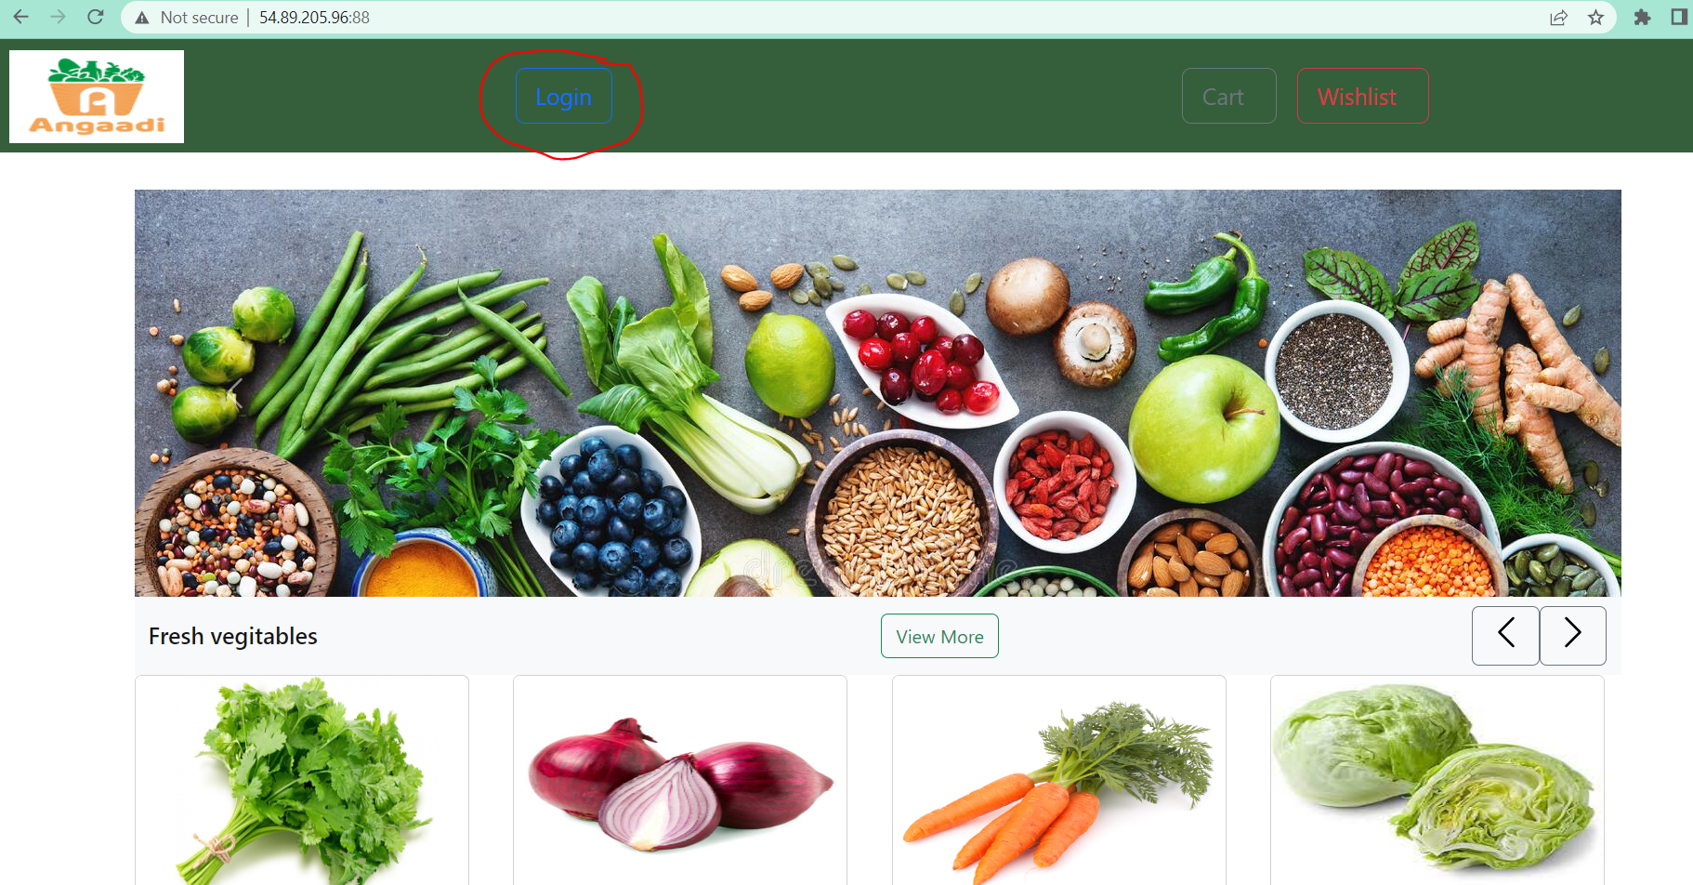

3.SignUp page will be visible,

* It contained Email and Password text boxes for registered user
* Also have Sign Up button for new user and Admin login button

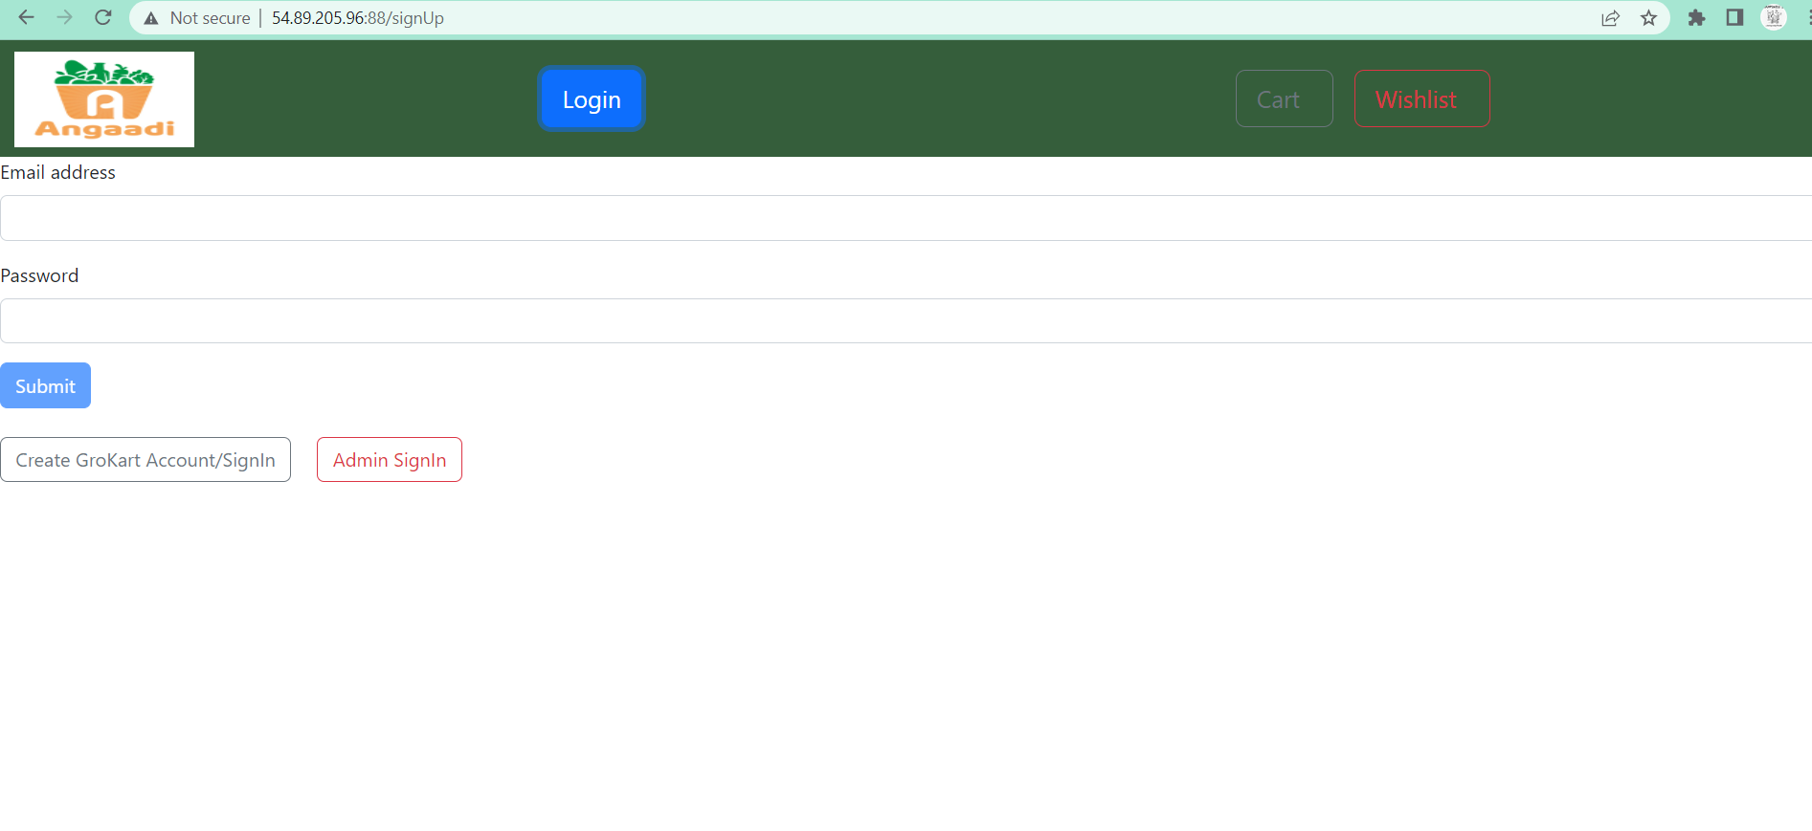

4.If the user doesnot provide Email and password, the below error message will be shown

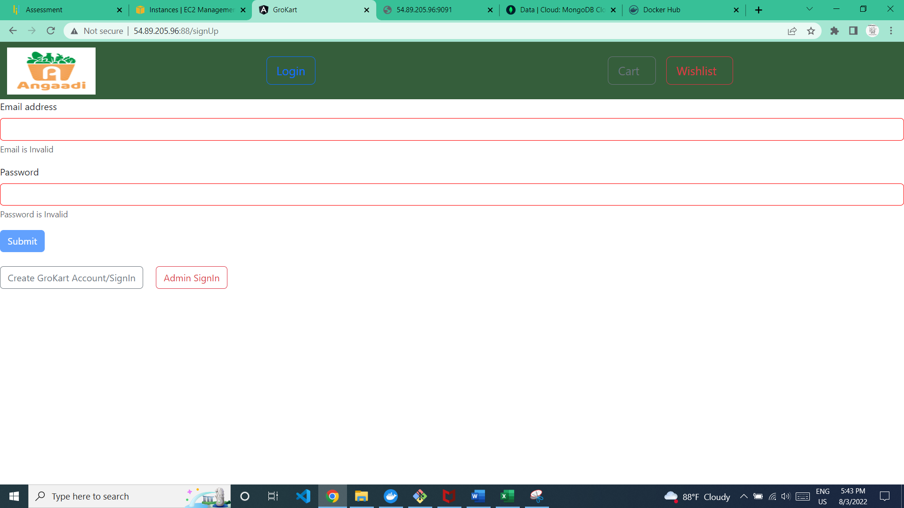

5. Submit button will be enabled only after entering email and password

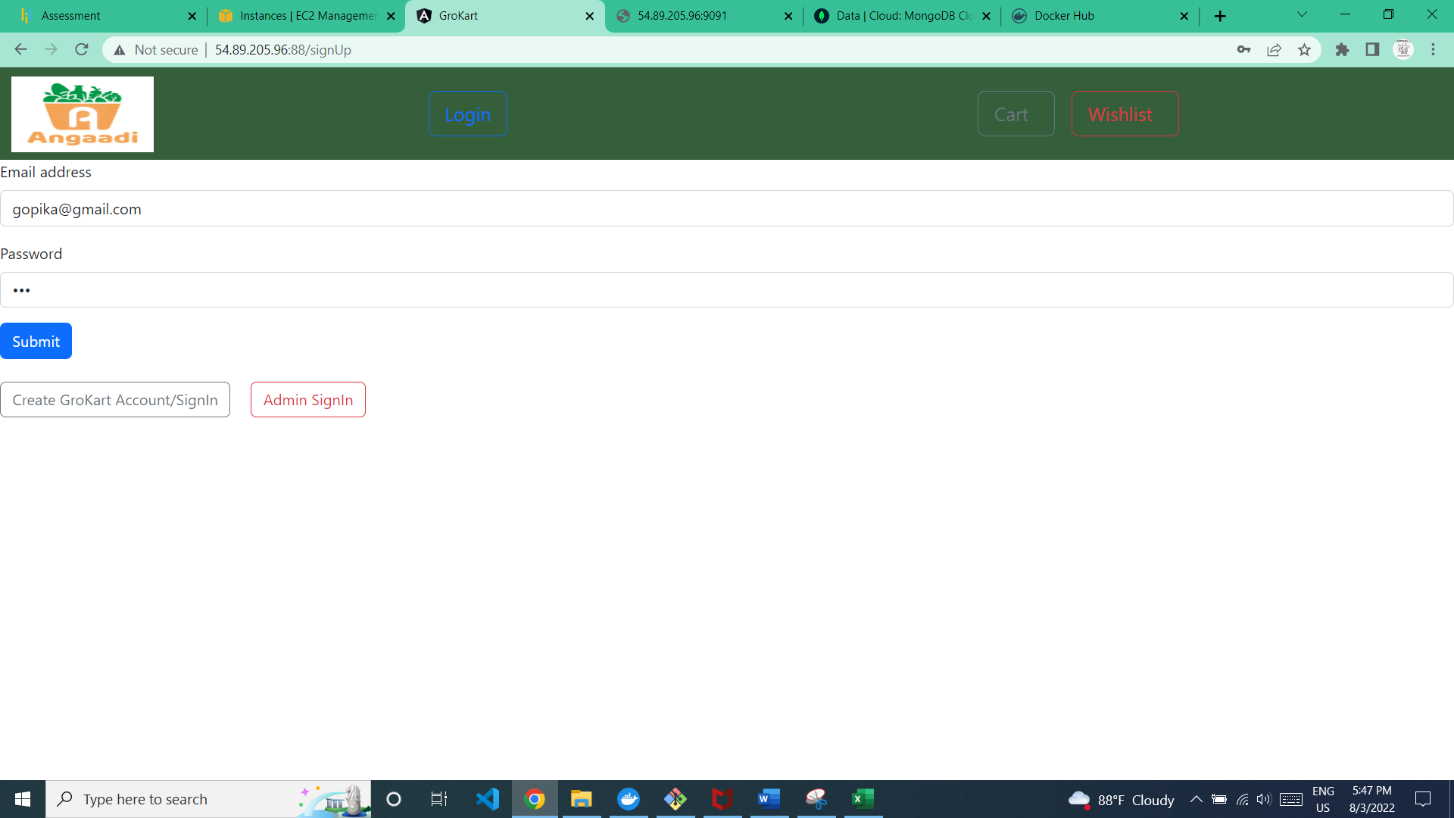

6.Once the user provide Email and password, the user will navigate to user page

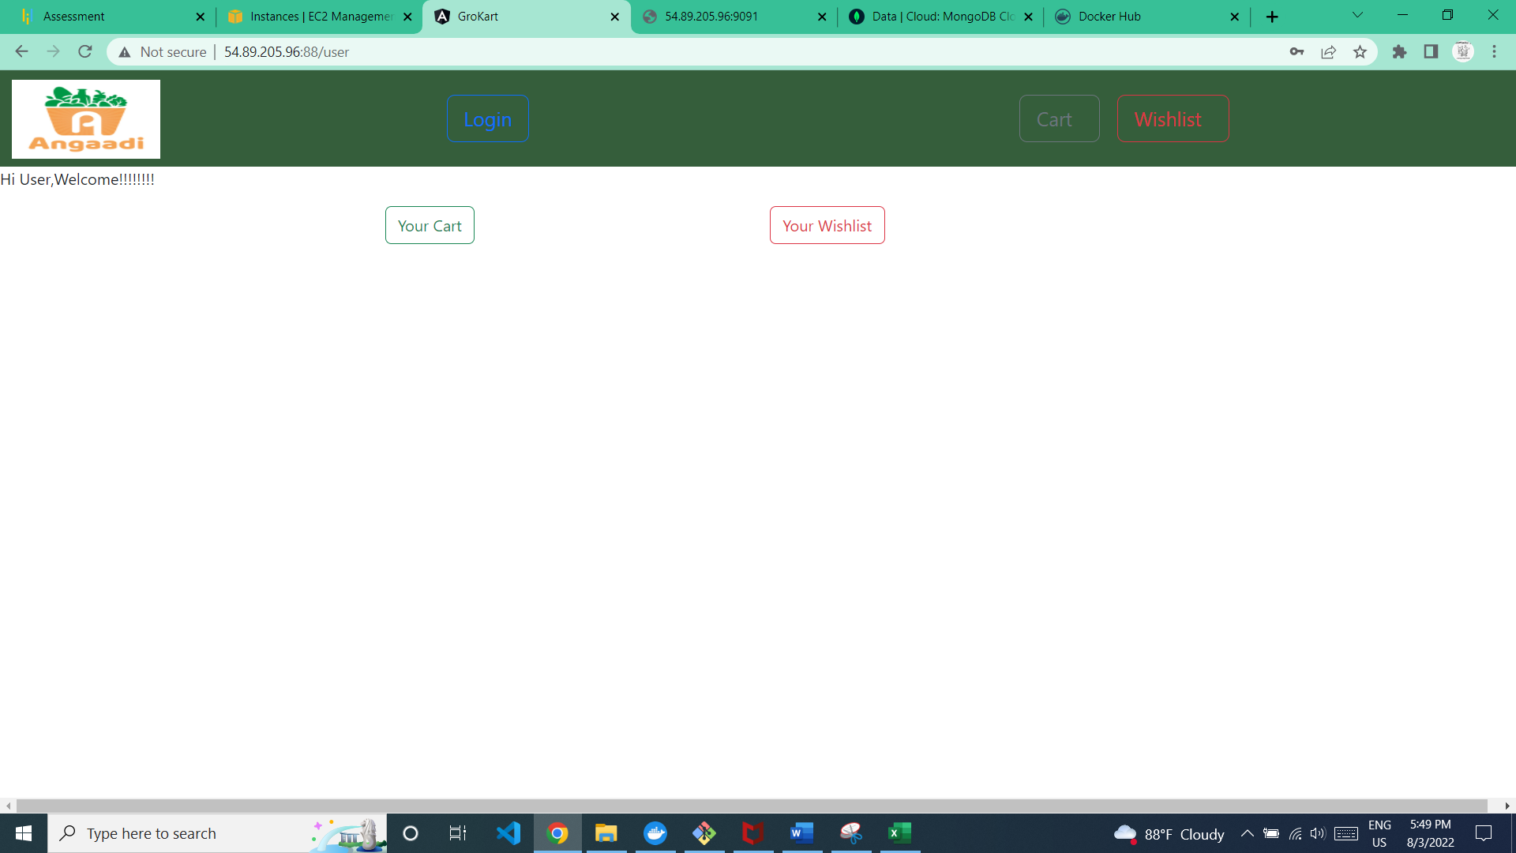

From this page user can go to the cart and wishlist

SignIn Page

1.Open the Home page(http://54.89.205.96:88/)

2.Click Login Button

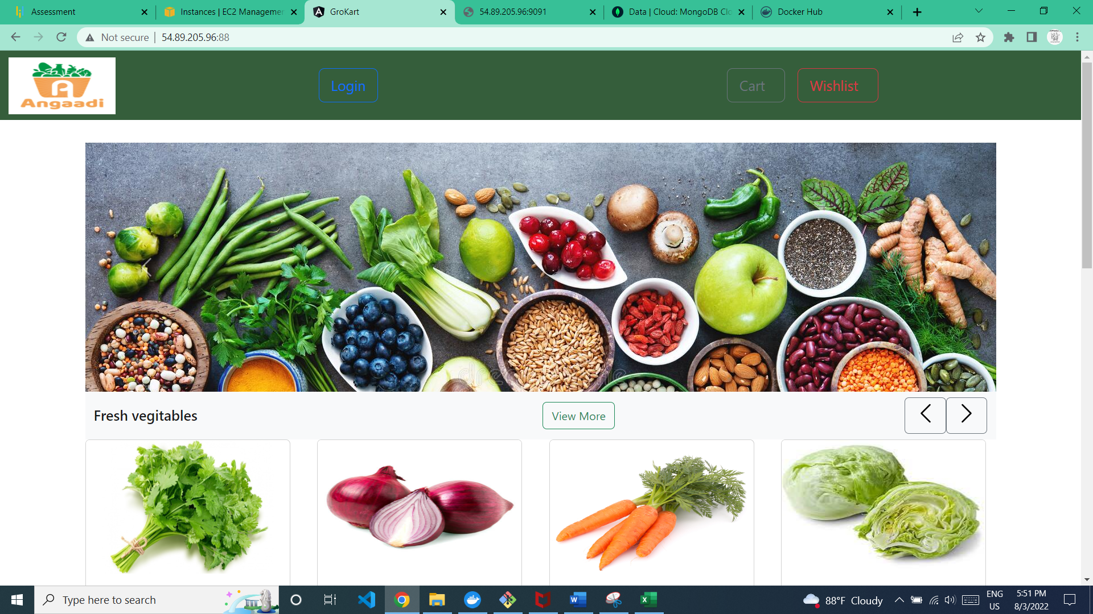

3.the user will navigate to signUp page

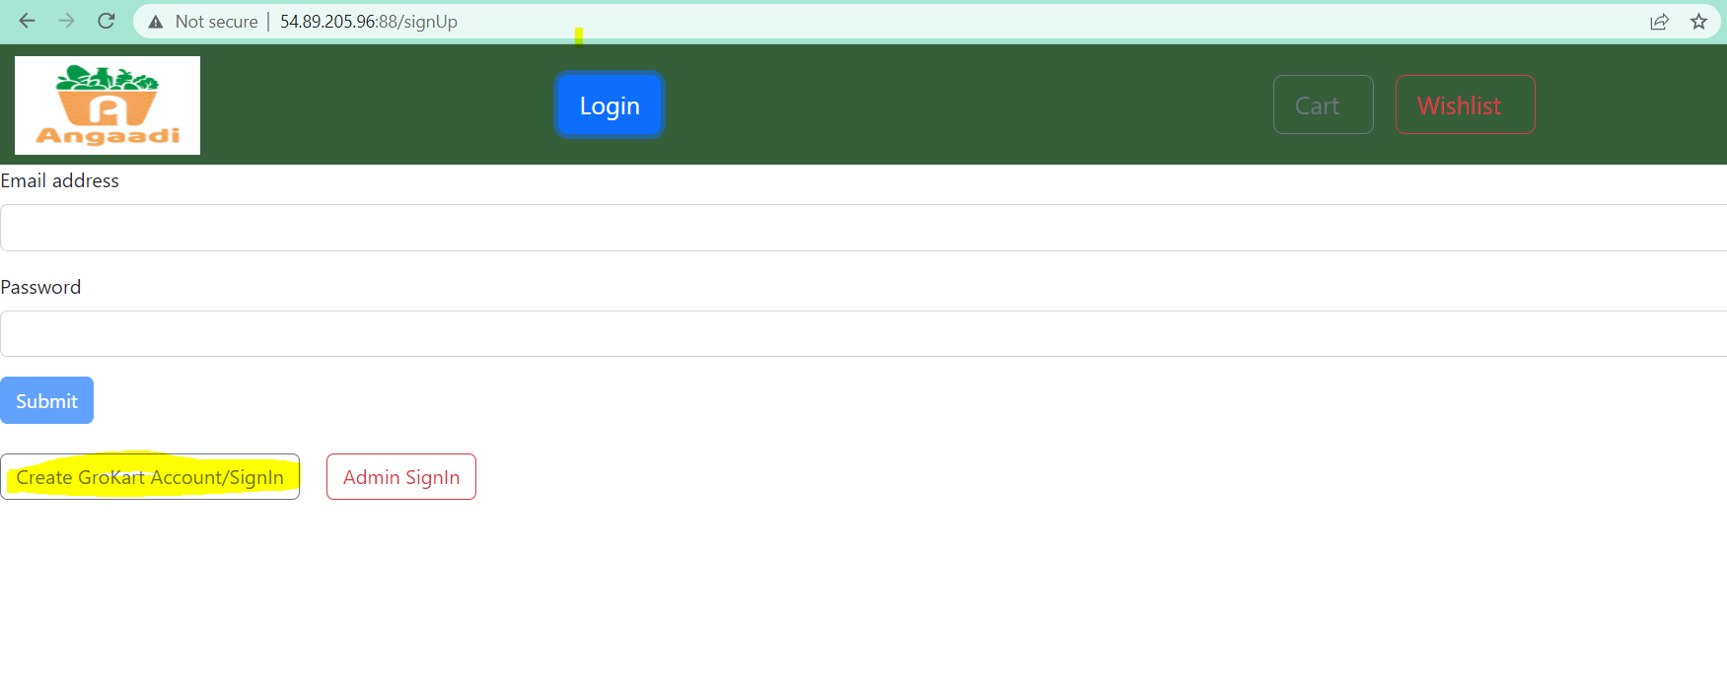

4.User should click on create GroKart Account/SignIn to start a new account

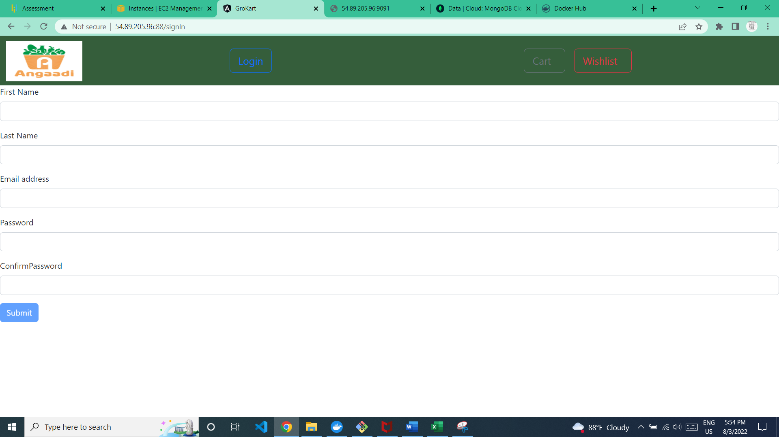

5.if we don not enter any values to the text boxes the below error messages will be displayed

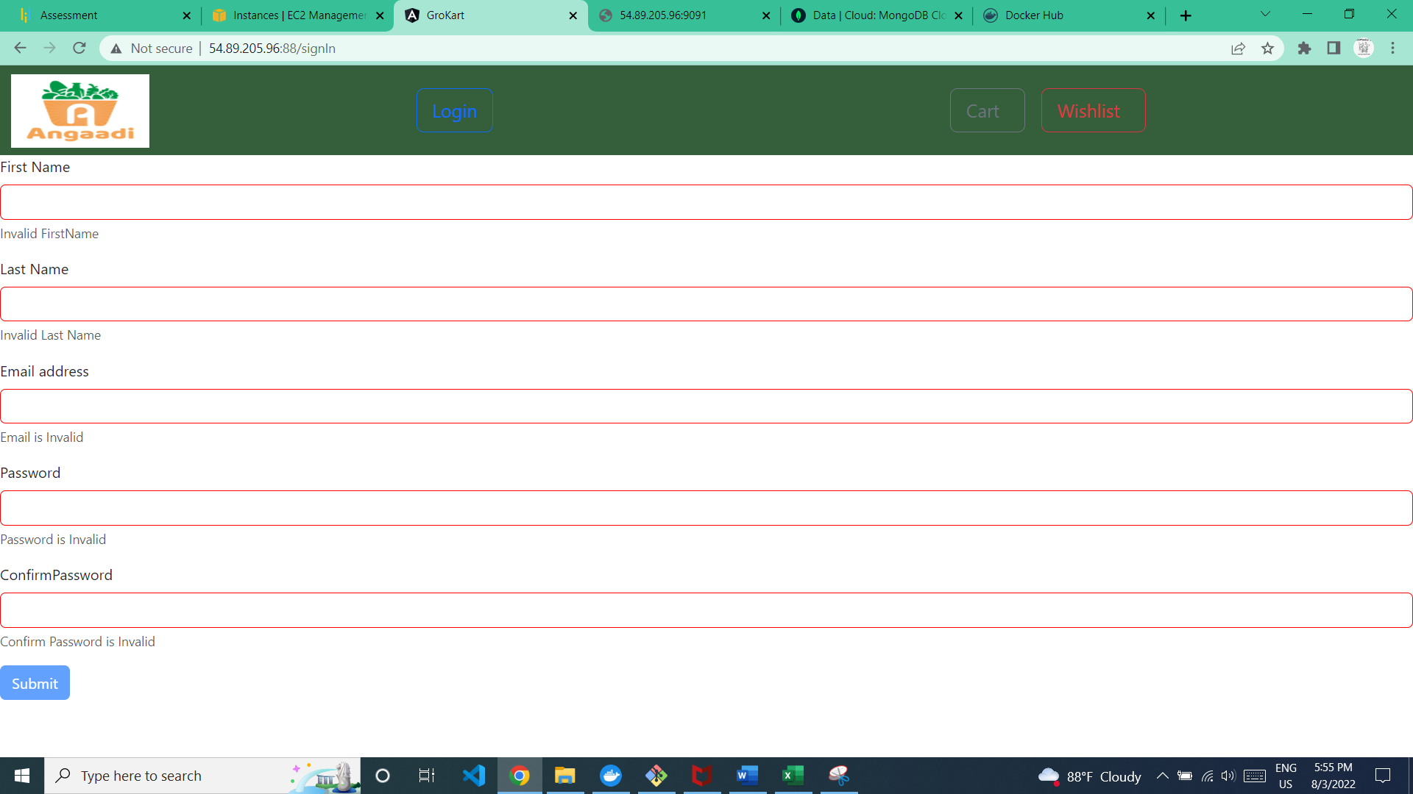

6.The first name and last name should have length between 3 to 30

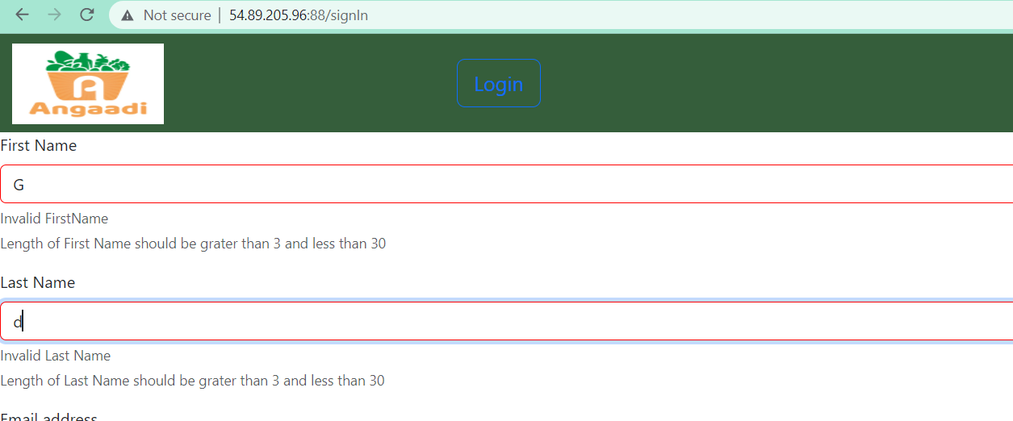

7.If the Email is not valid the below error message will be displayed

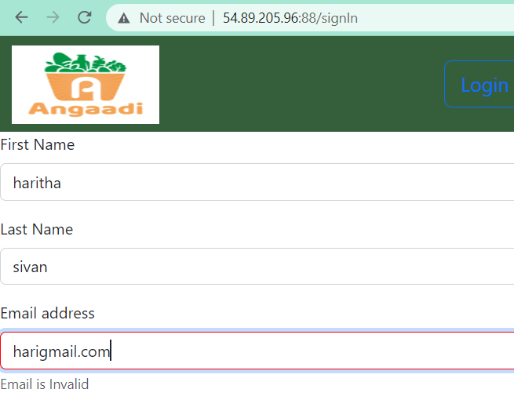

8.The password should have a length between 7 -30,otherwise it shows the below error message

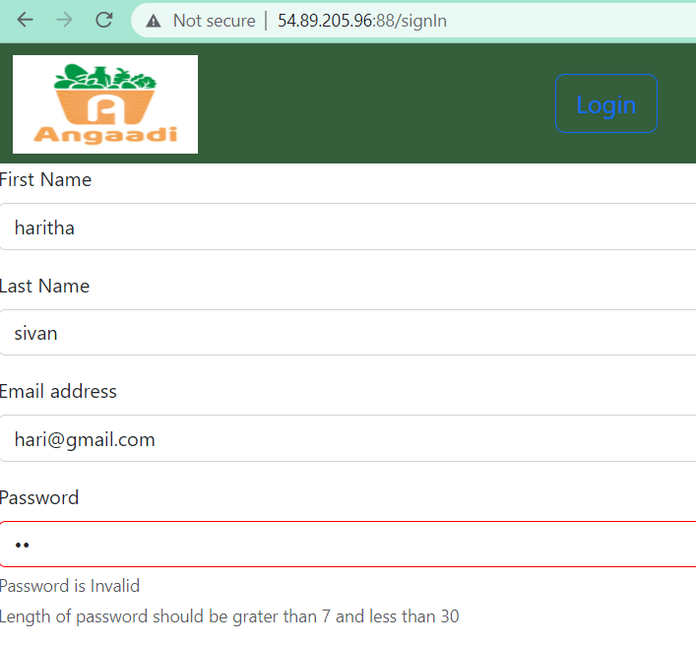

9.The password and confirm password should match,otherwise it should the below error message

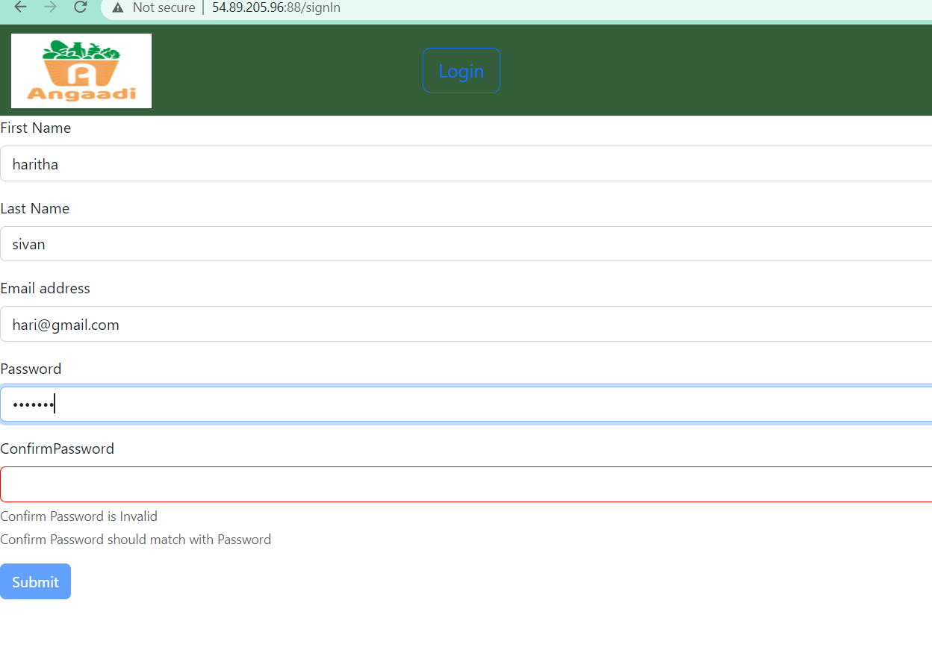

10.Once all the textboxes filled,the submit button will be enabled

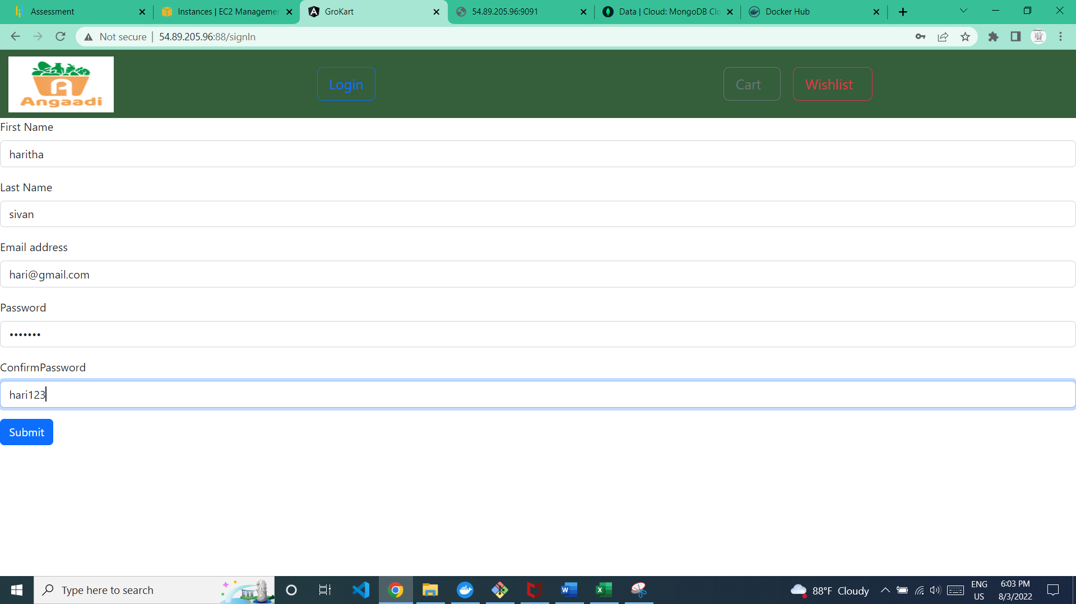

11.once click the submit button the user will be created

12.The user need to login with the register user email and password to login the grocery store.

User Page

1.Once user logins the user page will be visible

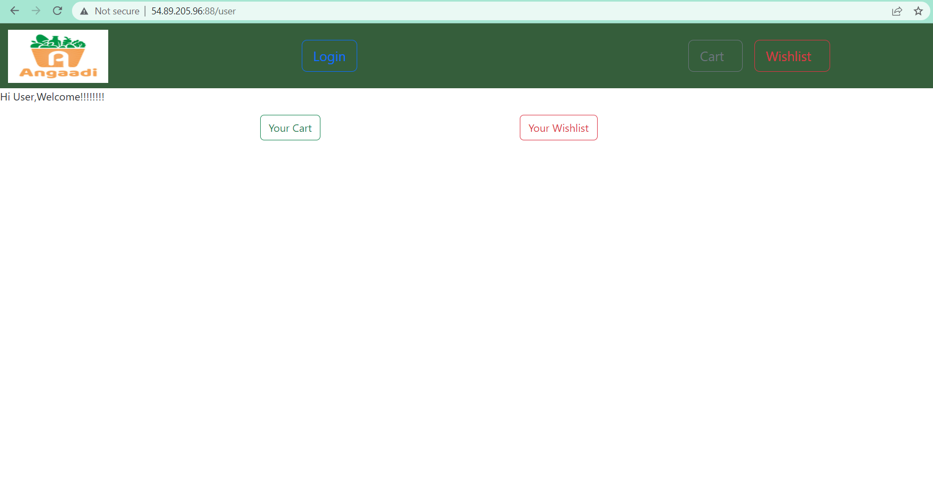

2.From here user can go to the cart page/Wishlist page

Cart page: Cart page have the groceries added to the cart , quantity,Price and total price

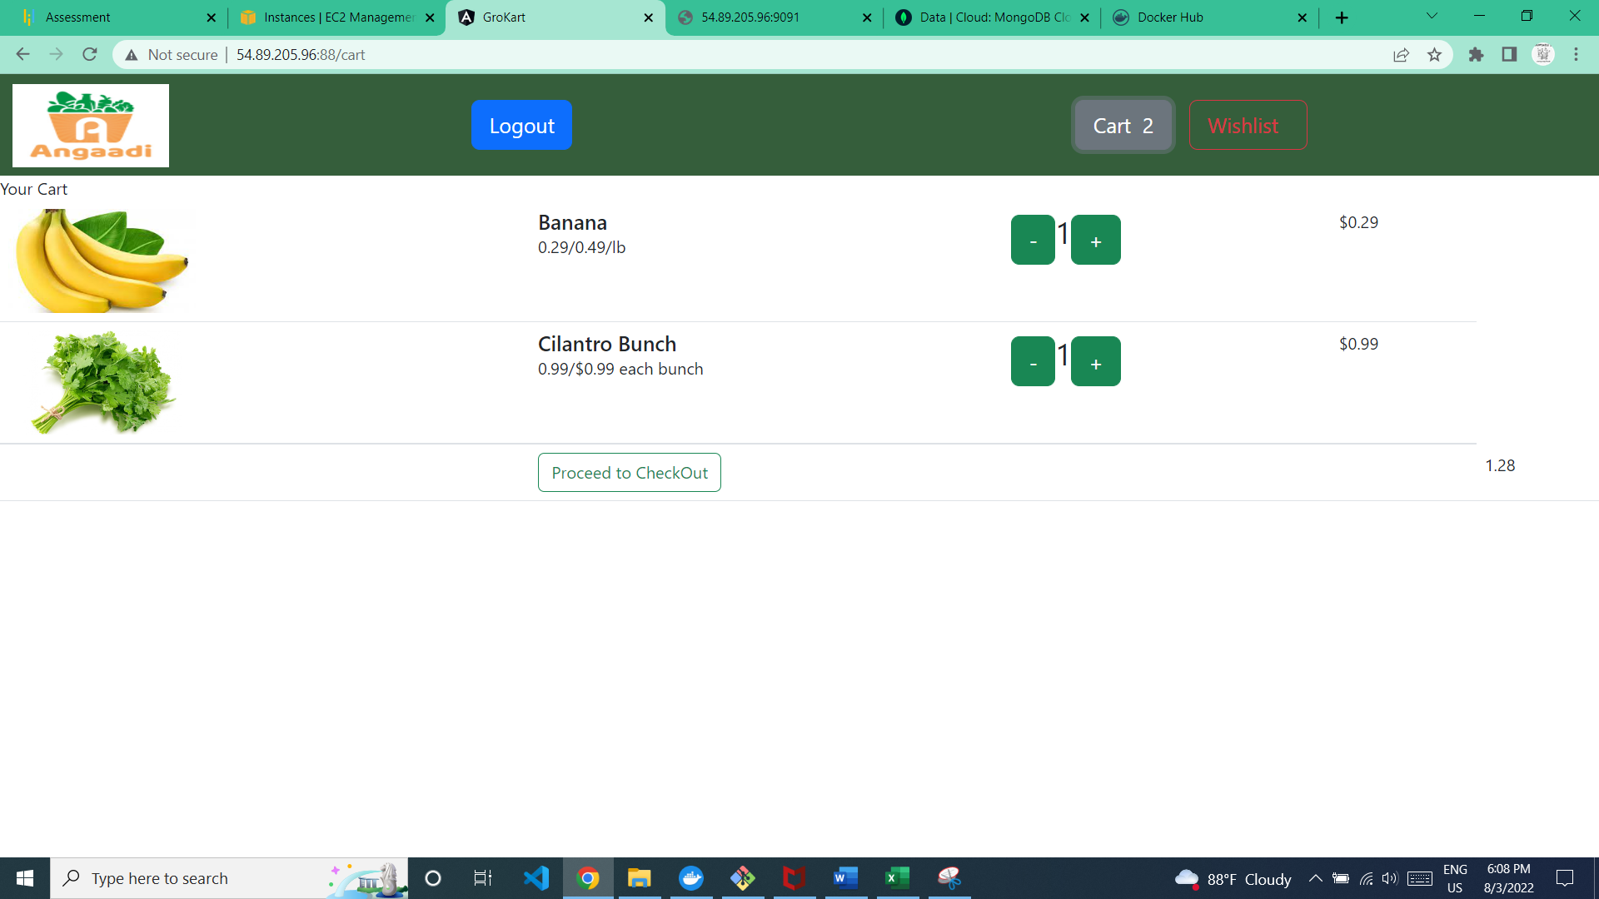

Wishlist page: wishlist page have the groceries added to the wishlist and Remove from wishlist button

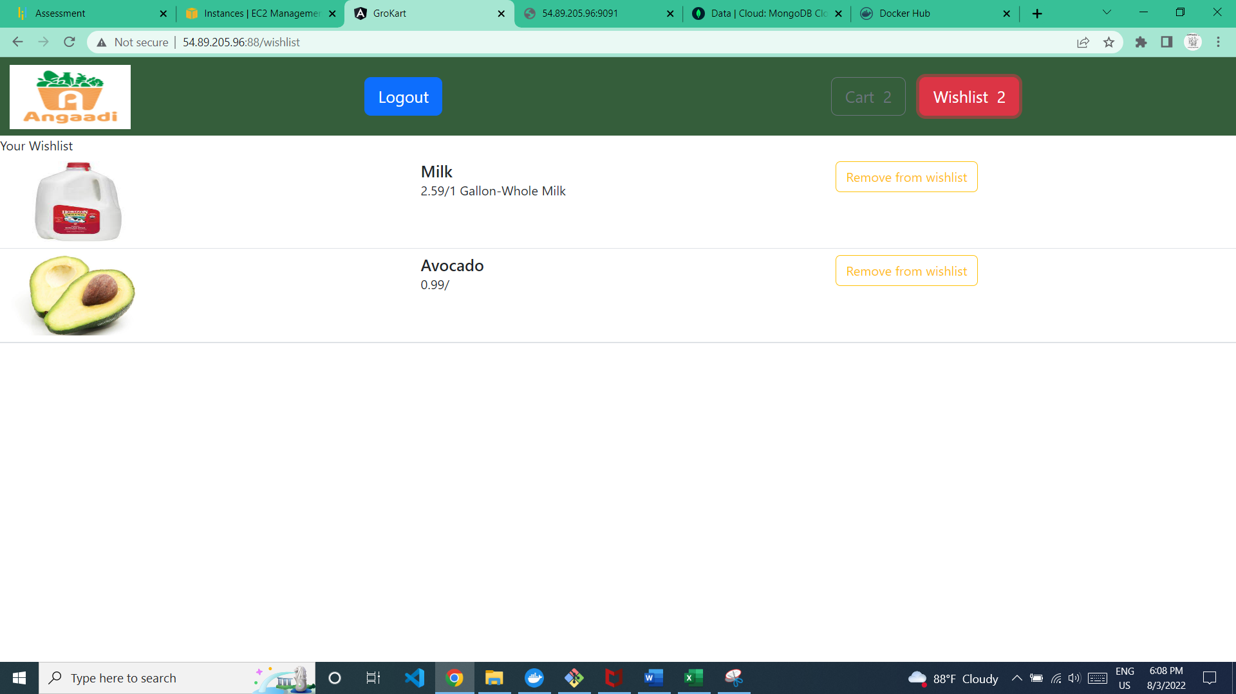

Cart

1.Open the Home page(<http://54.89.205.96:88/>) and login

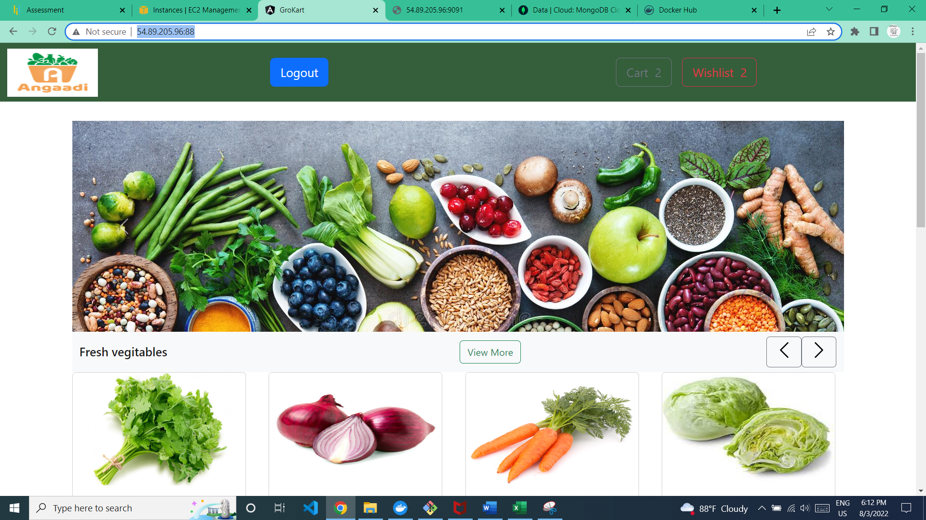

2.Click the cart

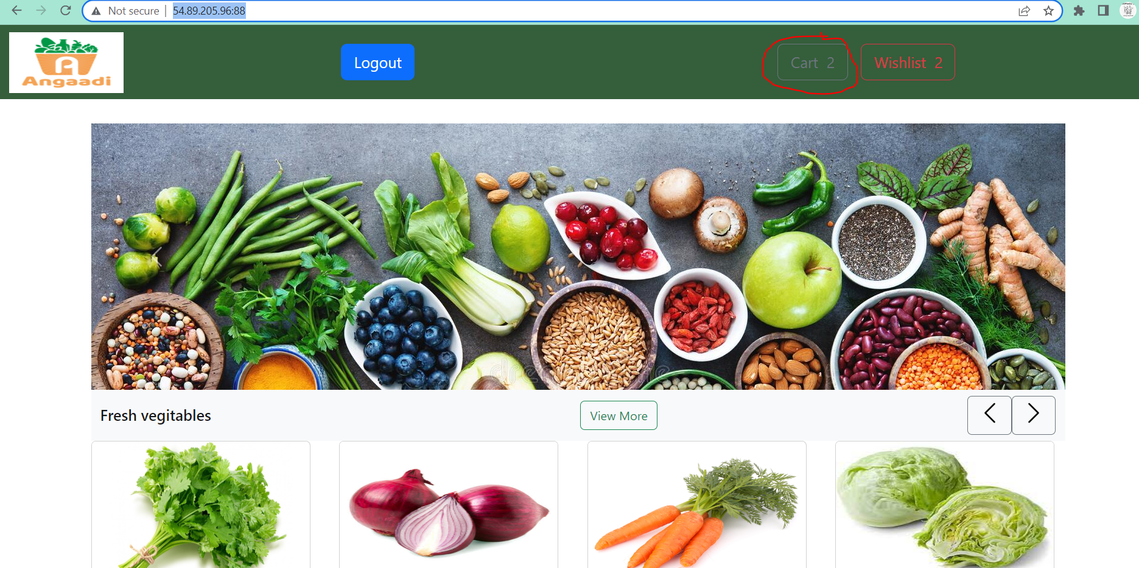

3.user will navigate to cart page

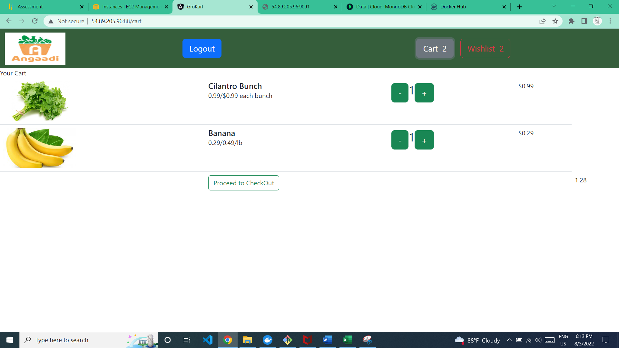

4.User can increment/decrement the quantity

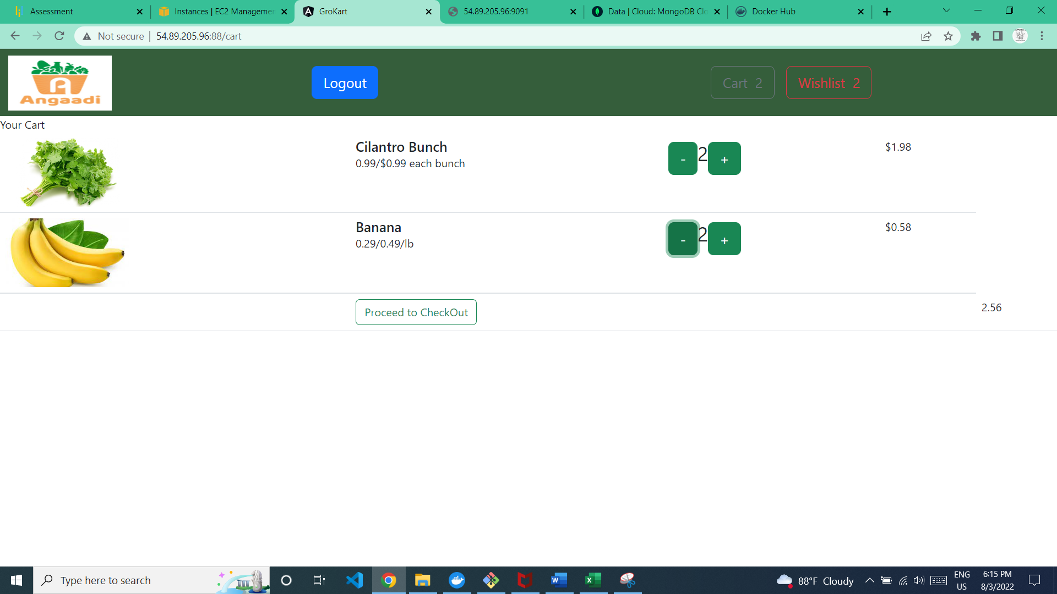

**NB:Proceed to checkout is not functioning.**

Wishlist

1.Open the Home page(<http://54.89.205.96:88/>) and login



2.Click the wishlist

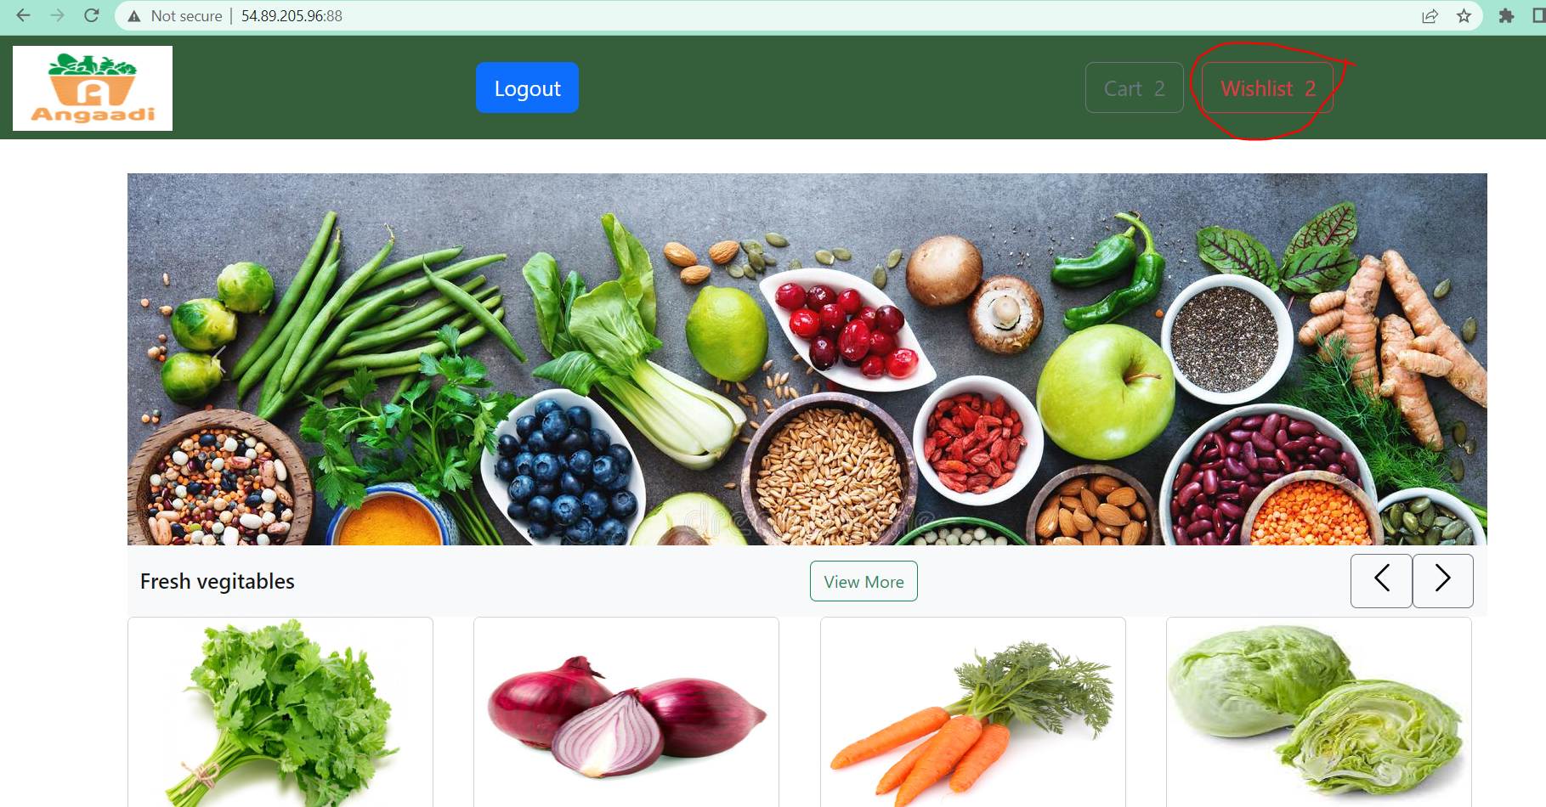

3. Wishlist page have the groceries added to the wishlist and Remove from wishlist button

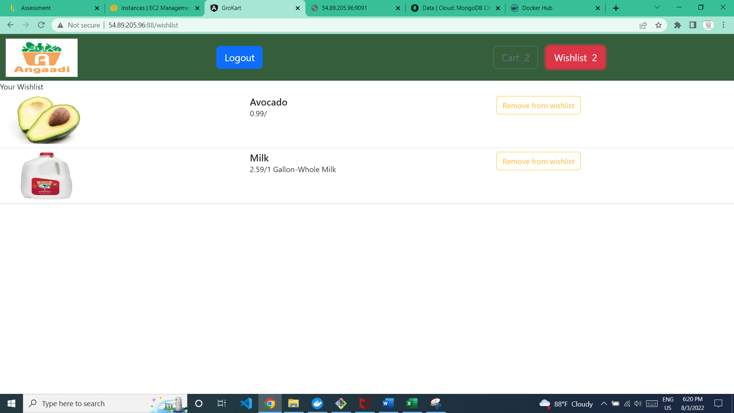

4.Once the user clicks on Remove from Wishlist the grocery item will be removed

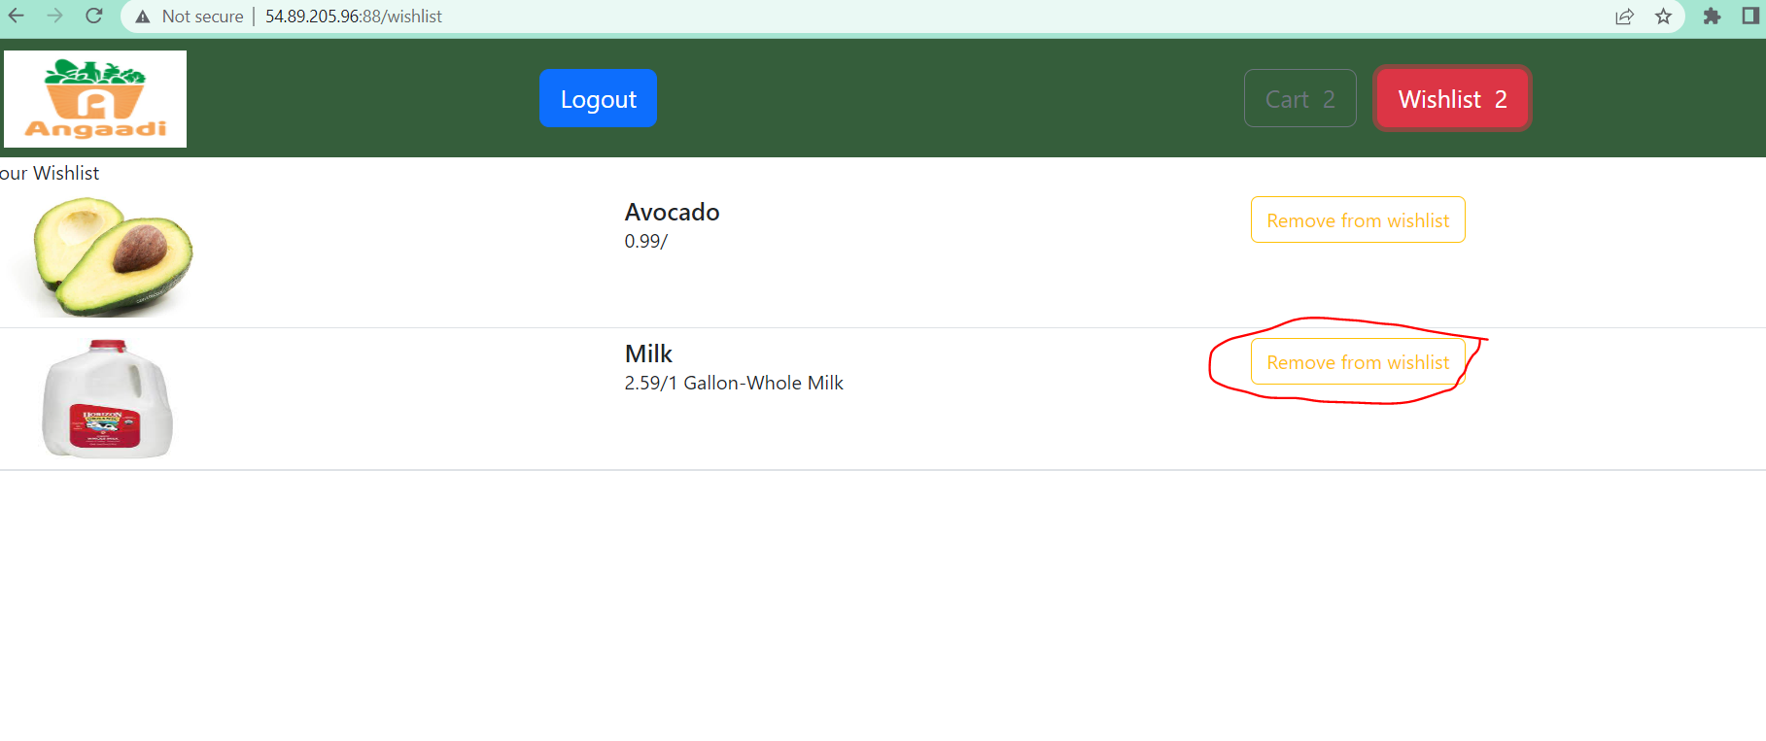

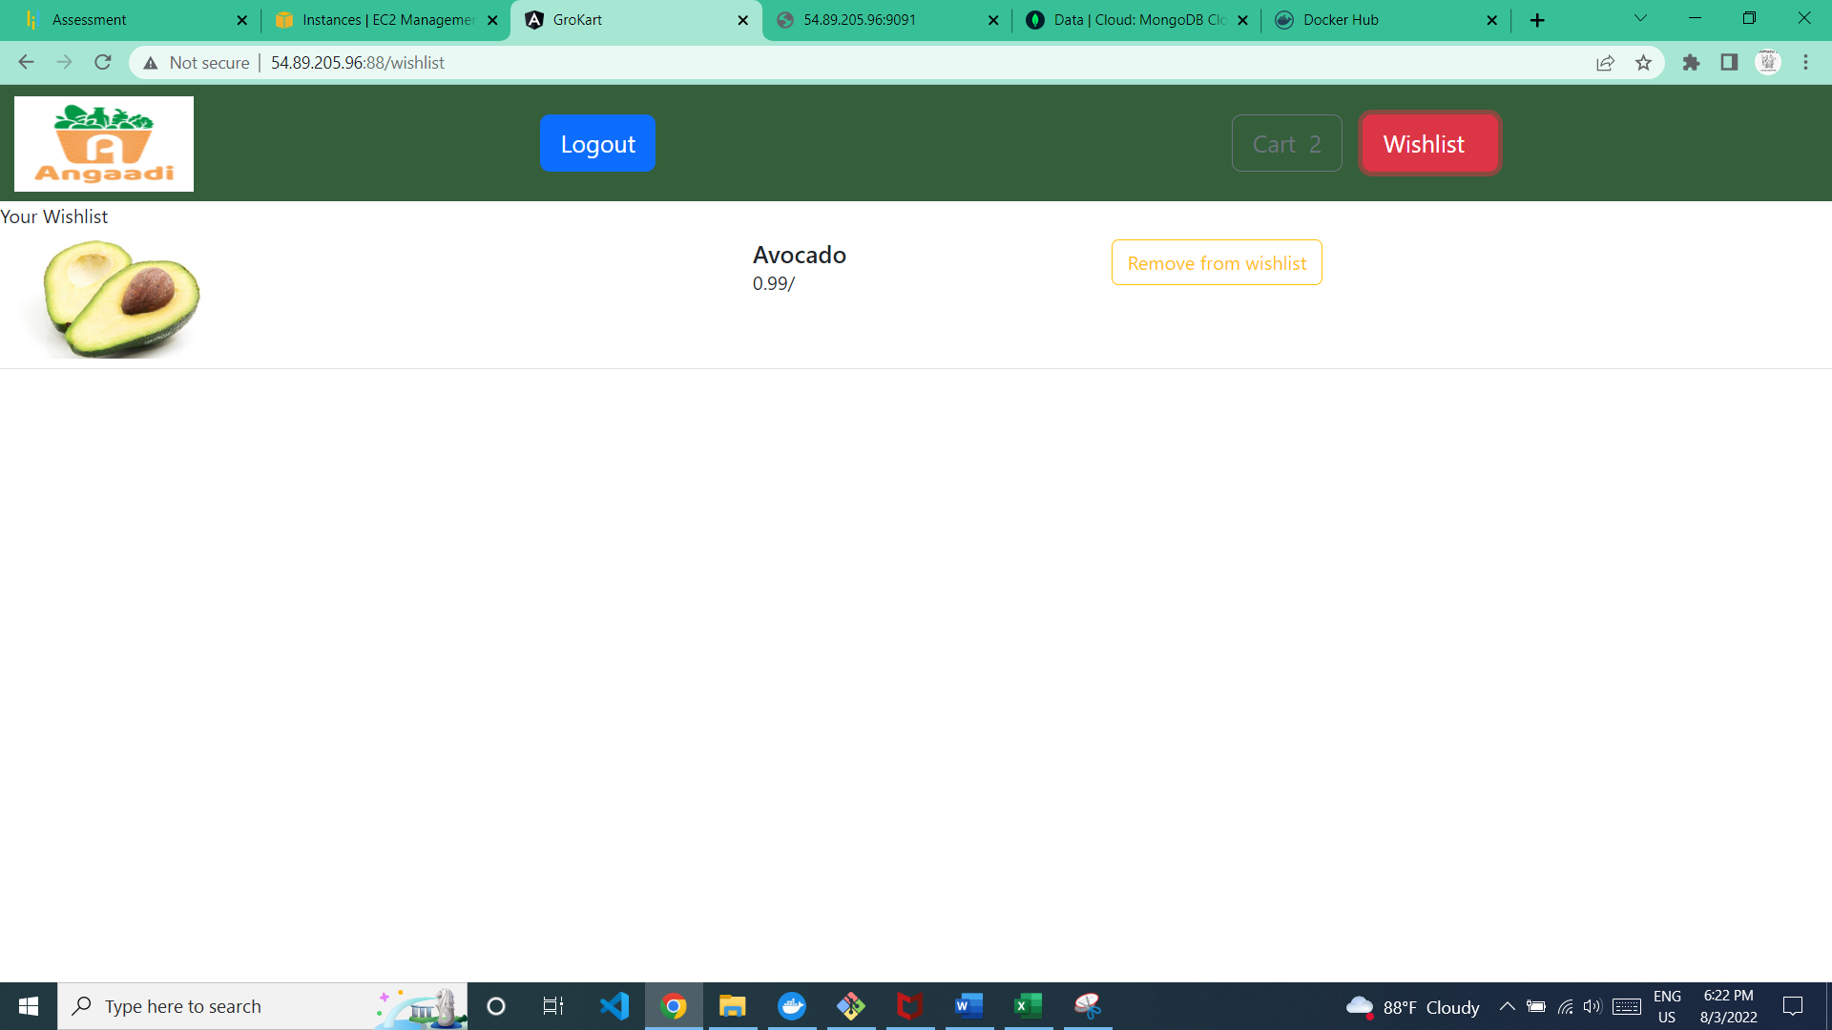

Admin Page

1.Add new admin

1. Add a new user using SignIn

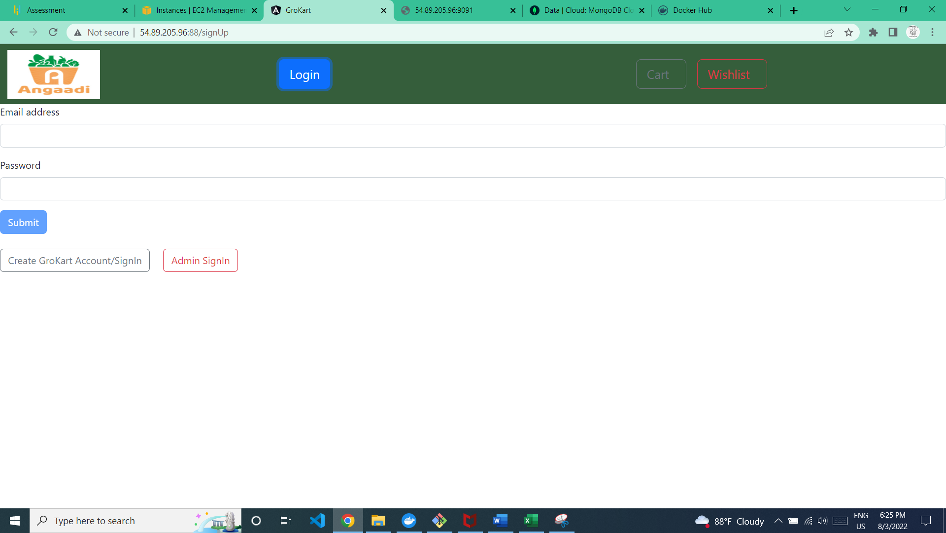

2.Add a new field as role as admin in database

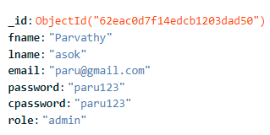

1.Open the website(http://54.89.205.96:88/)  
2.Click Login Page  
3.Click on Admin Login button

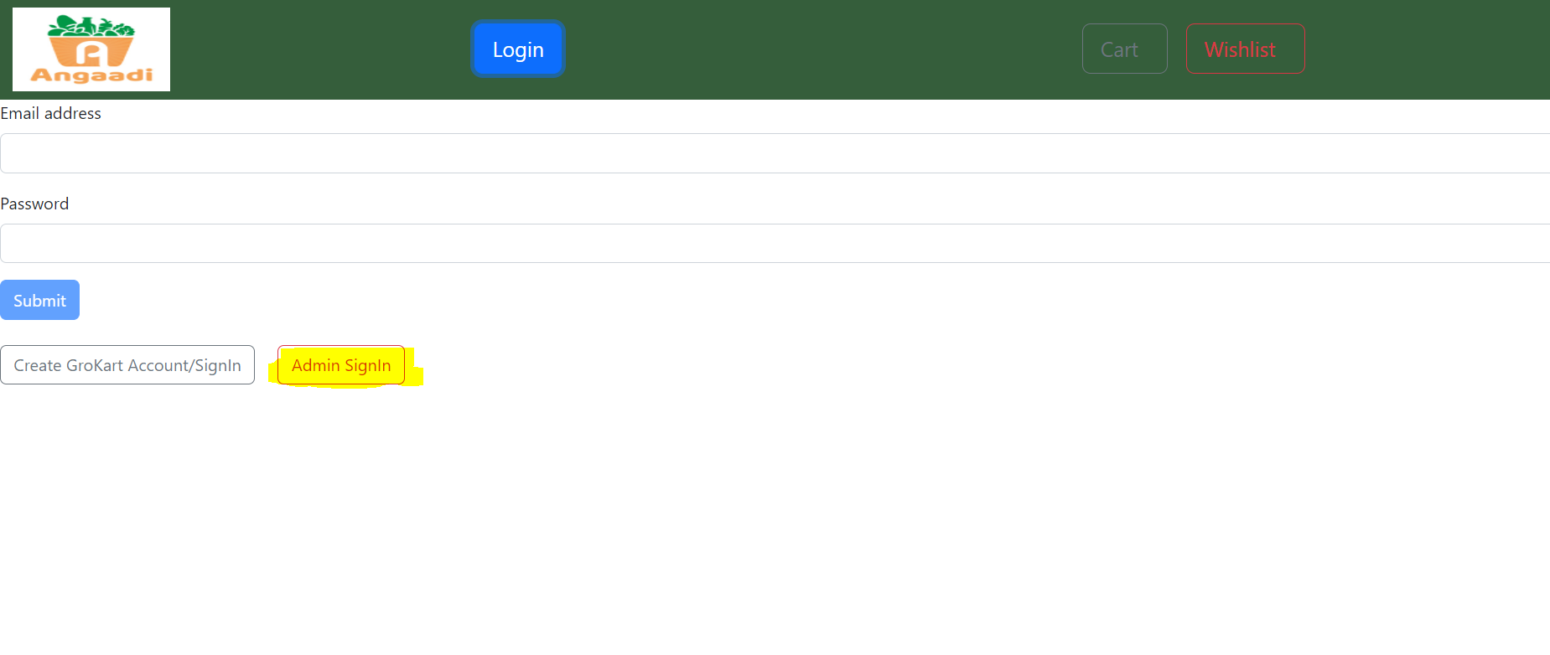  
4.User should provide valid email and password

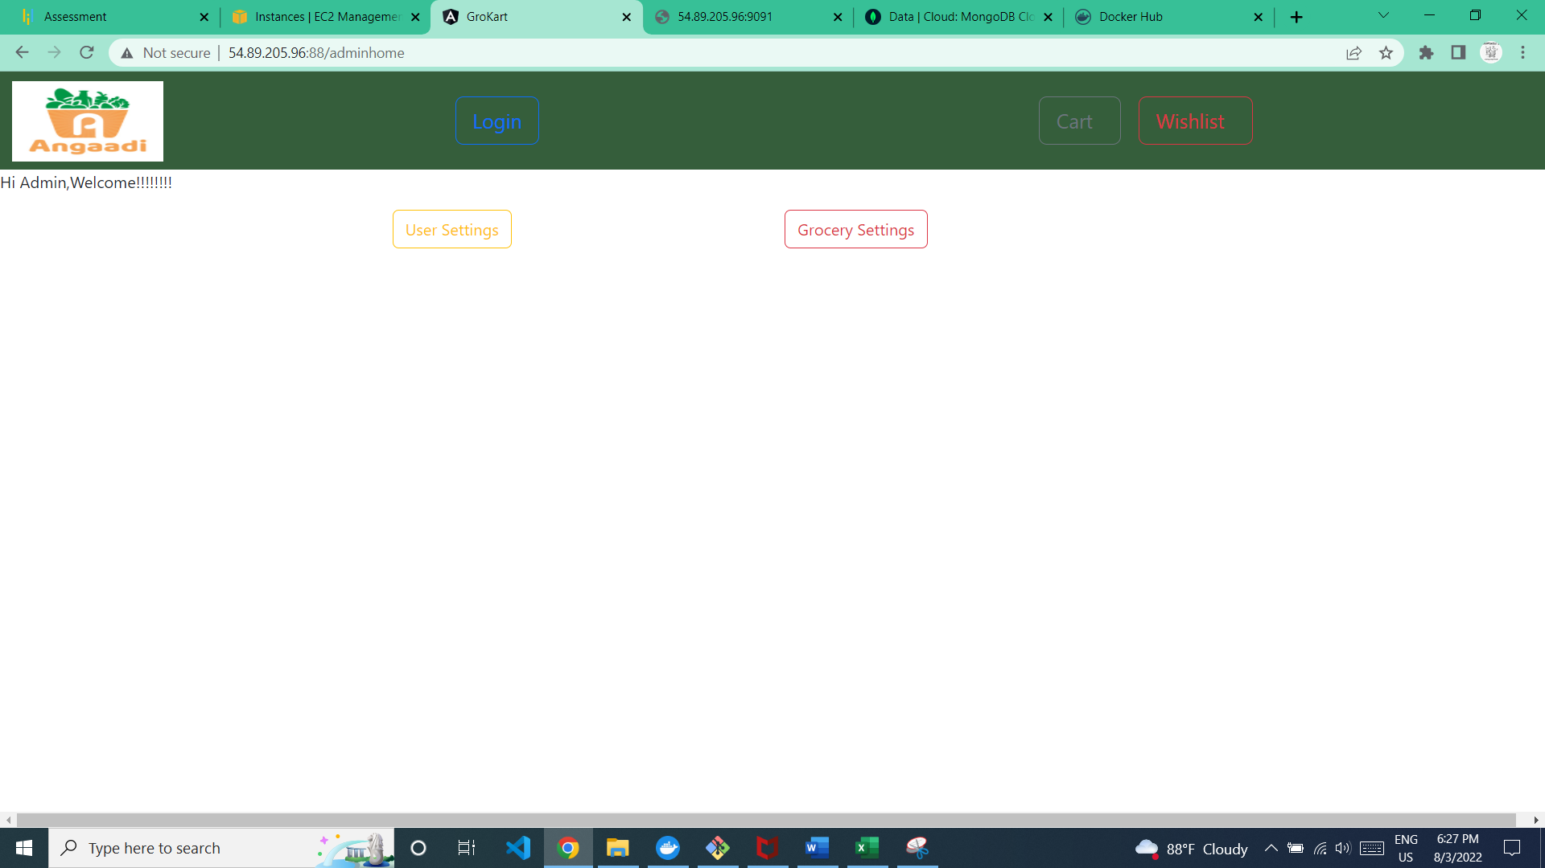

**User Settings**

1.click on the User settings from Admin page

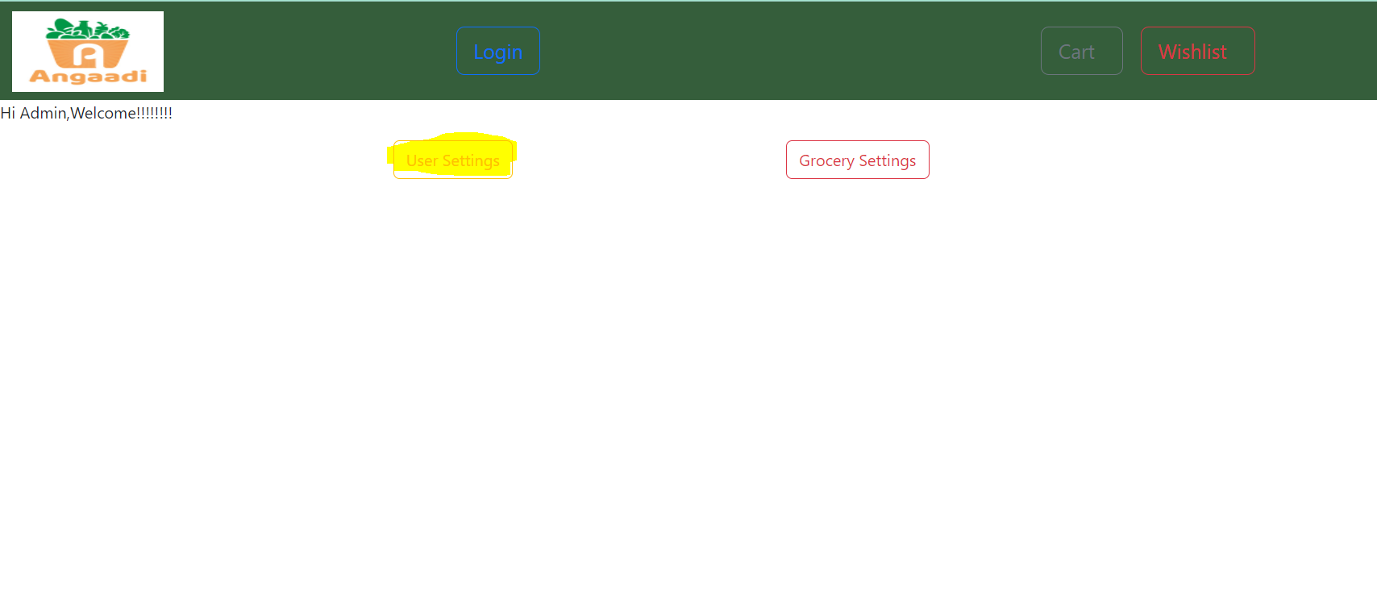

2.All the user details will be displayed

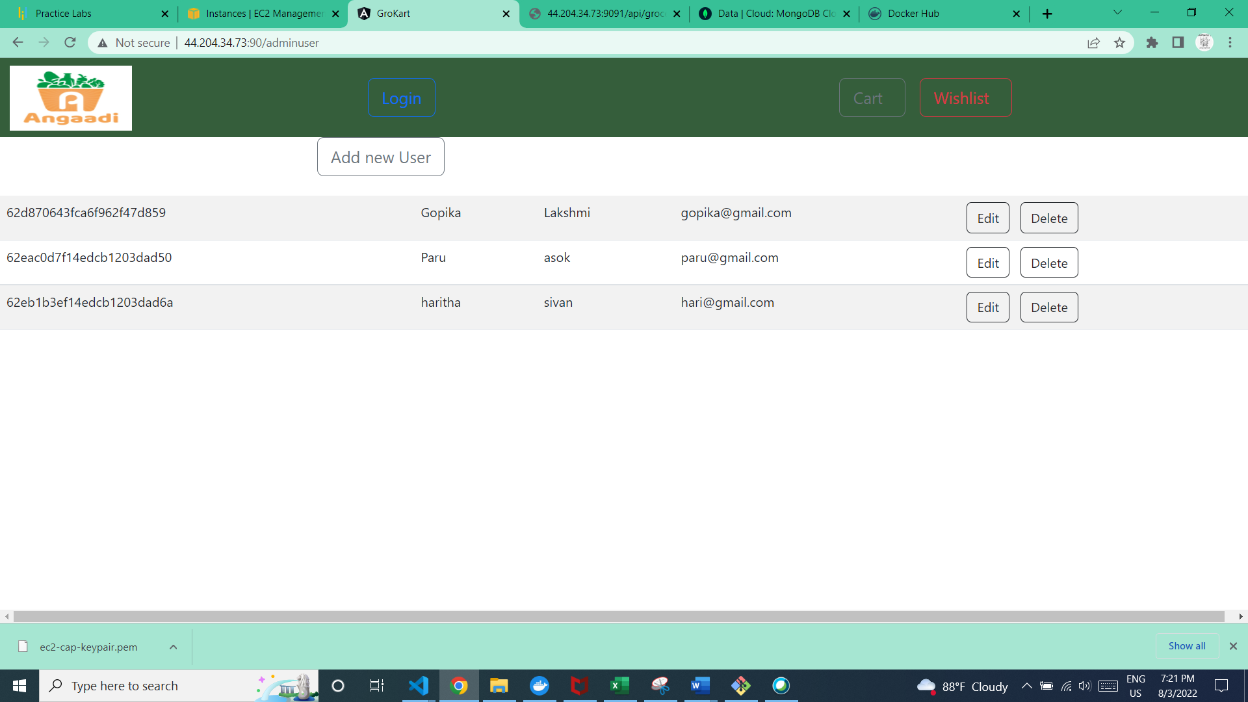

**Add new user**

1.click on Add new user button

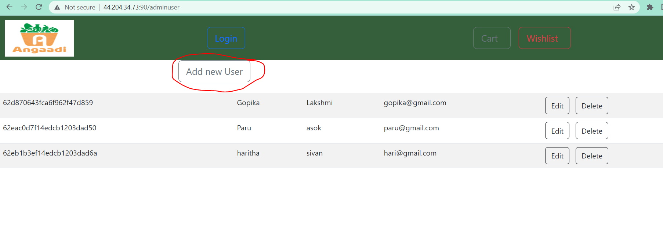

2.Fill all the field,All the fields are manadatory and click submit

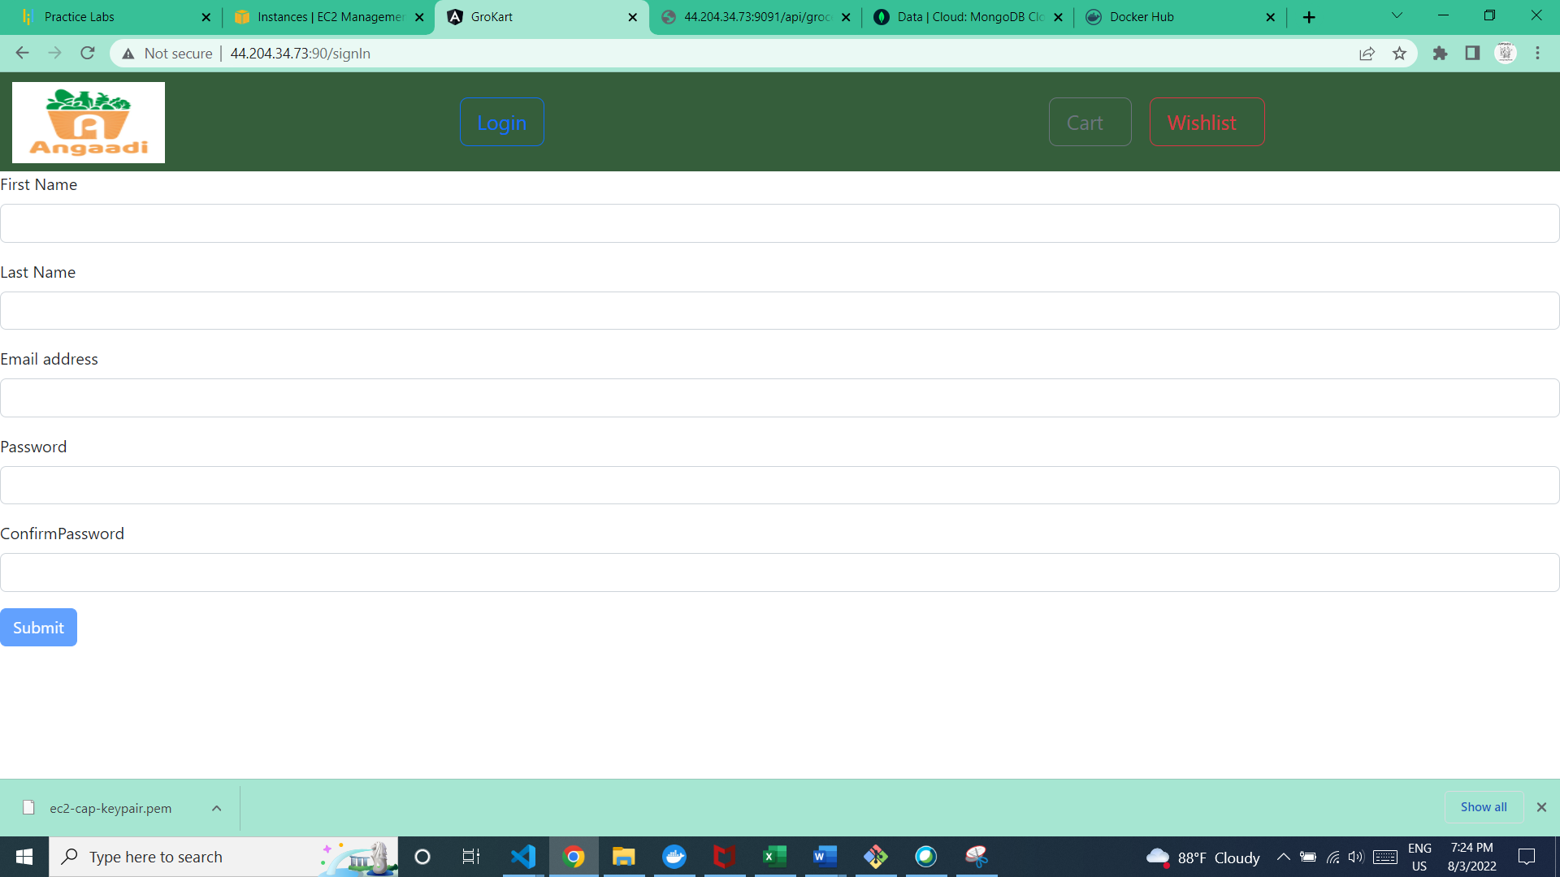

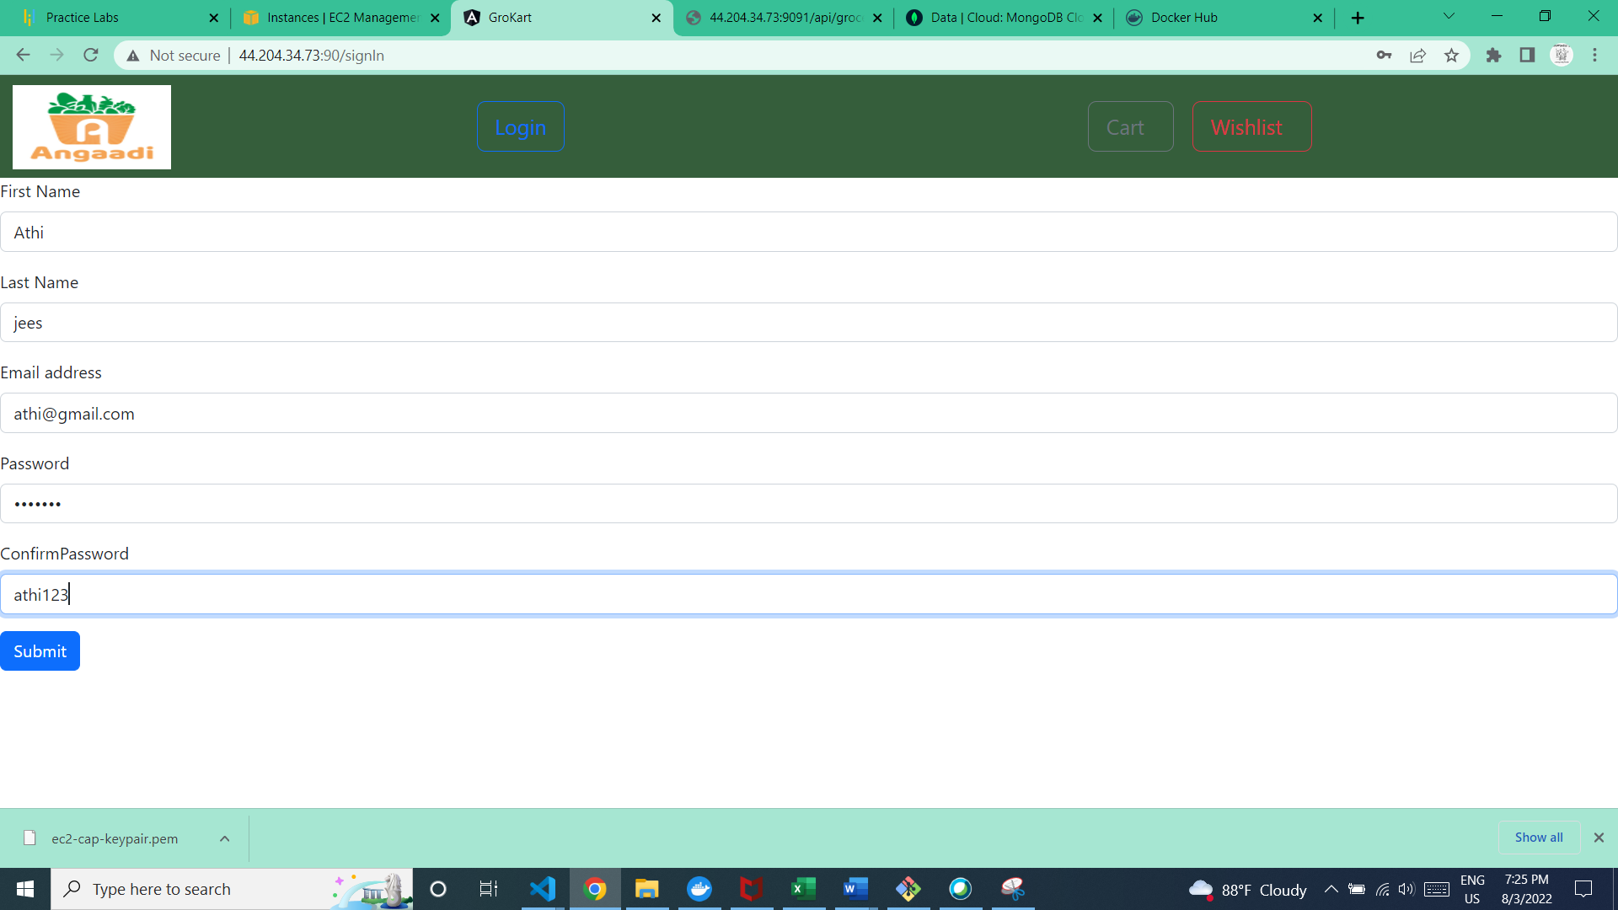

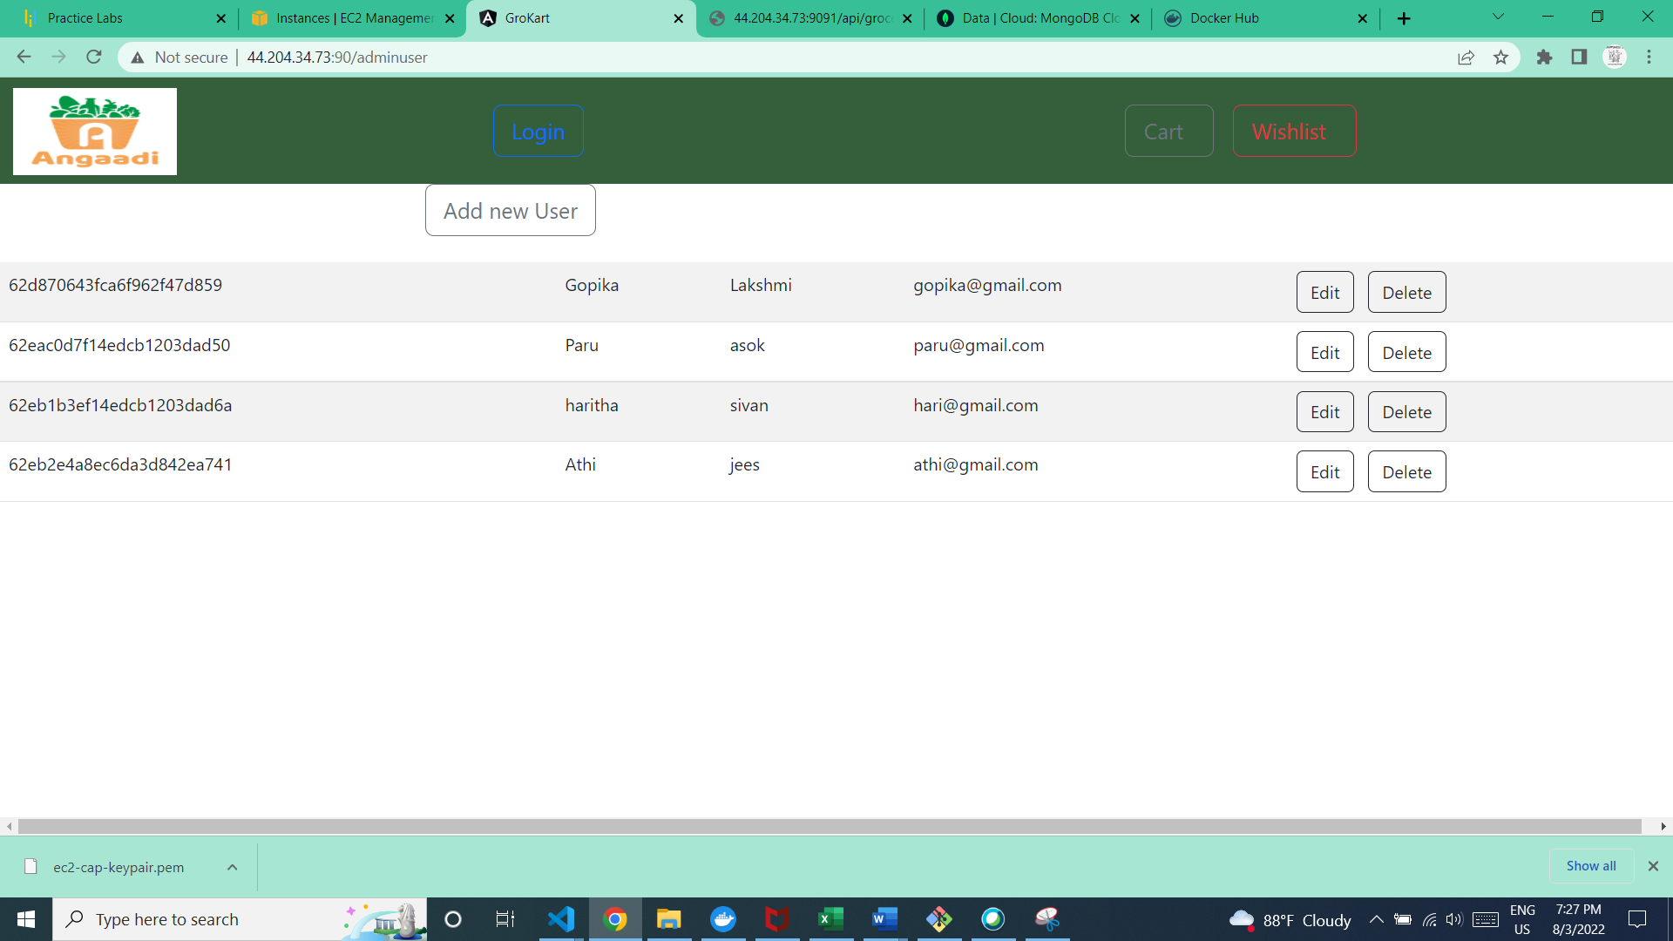

New user is added

**Edit User**

1.click on edit button

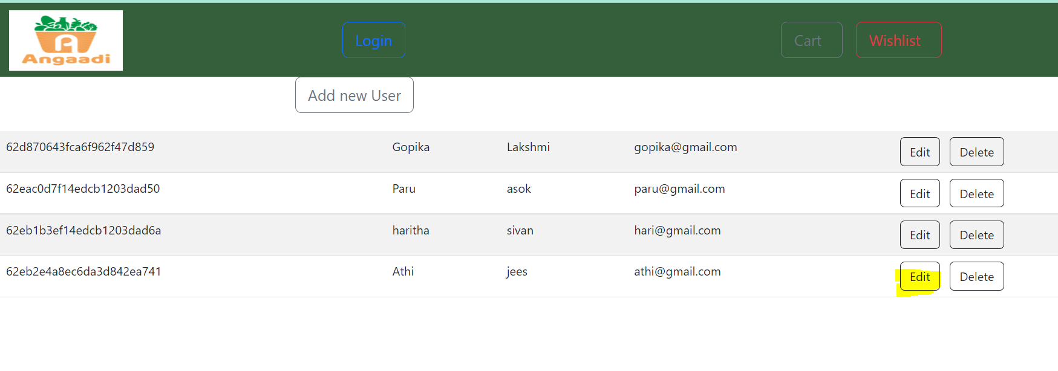

2.edit page will be displayed

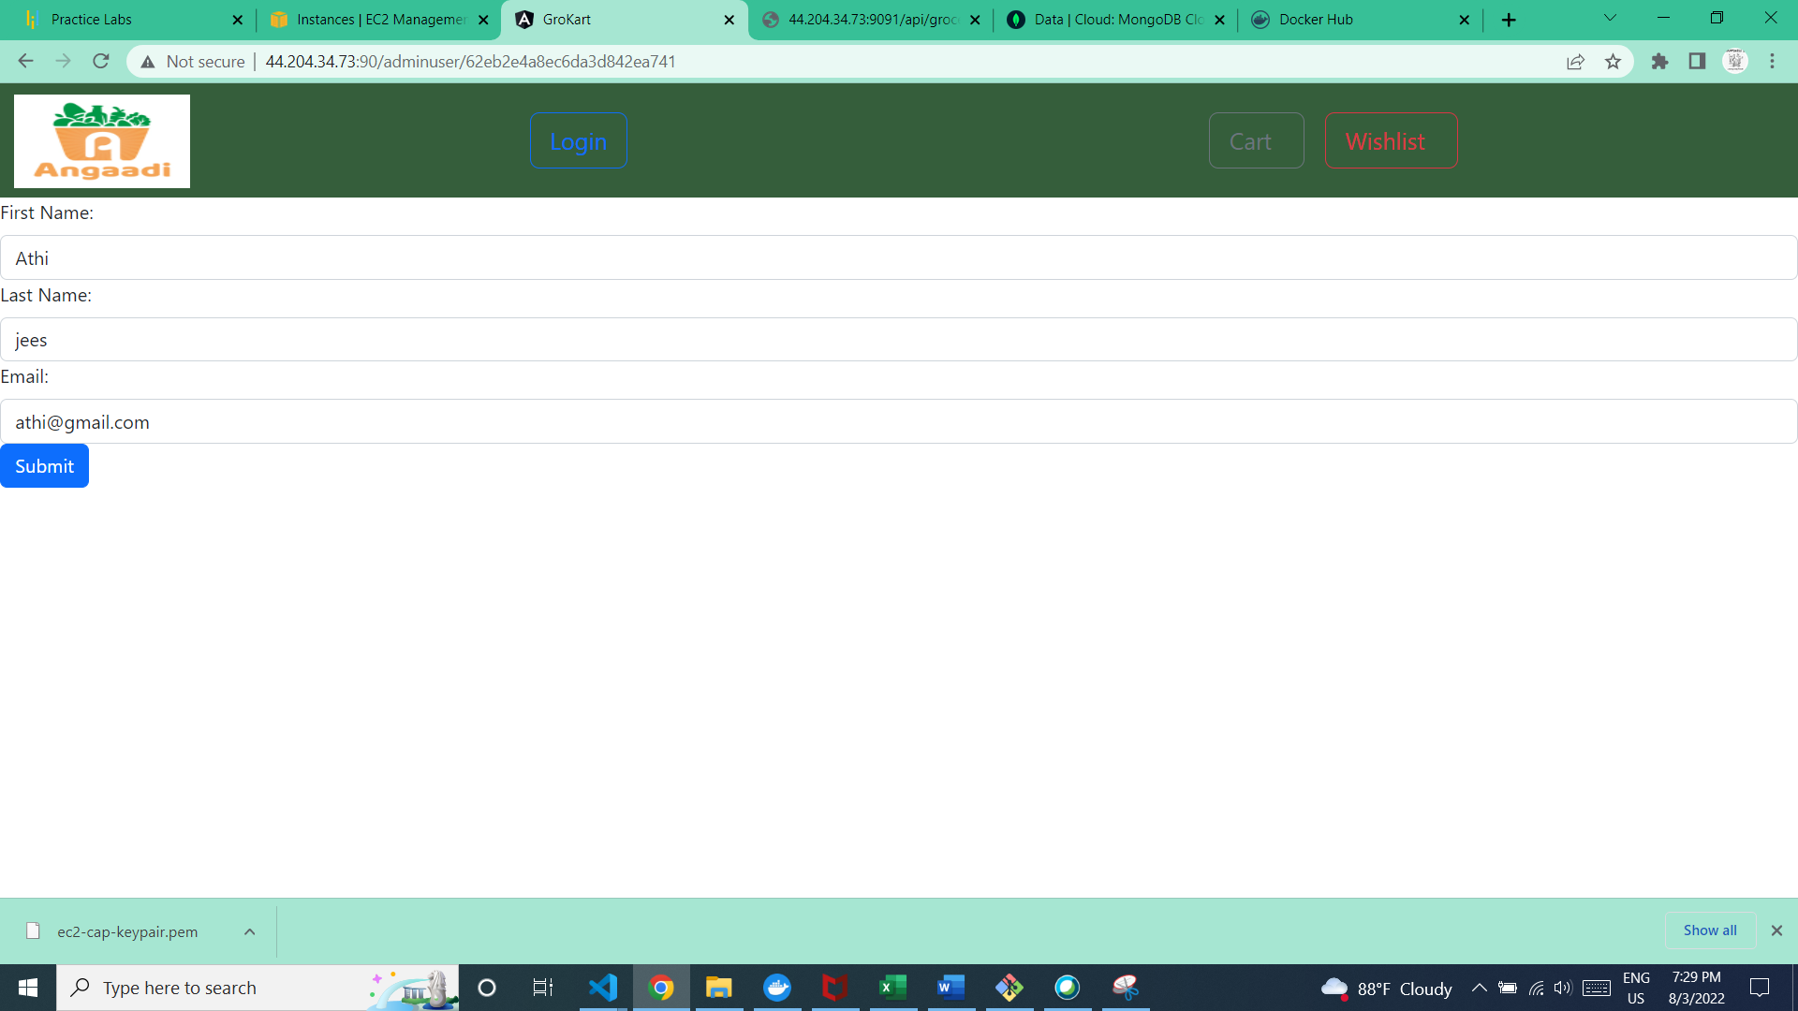

User can edit from this page and click submit button

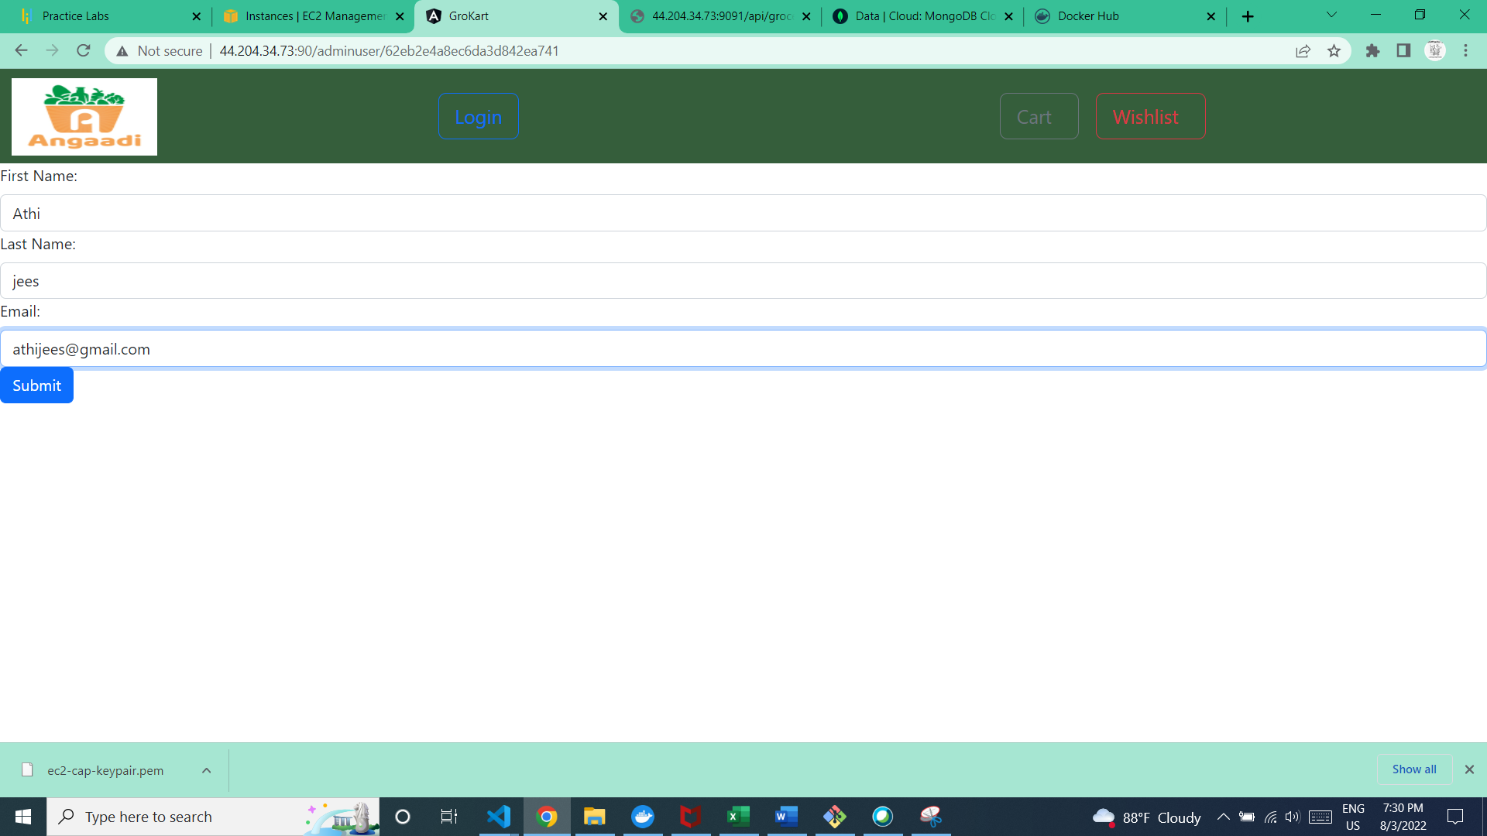

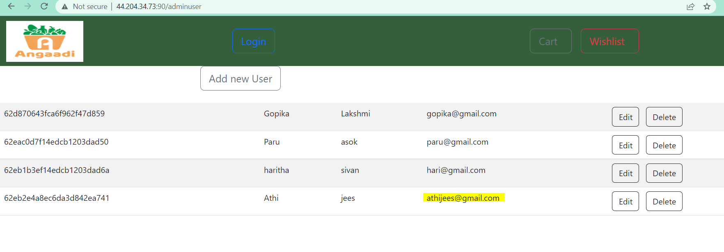

Email address updated

**Delete User**

1.Click on delete button for a user you wanted to remove

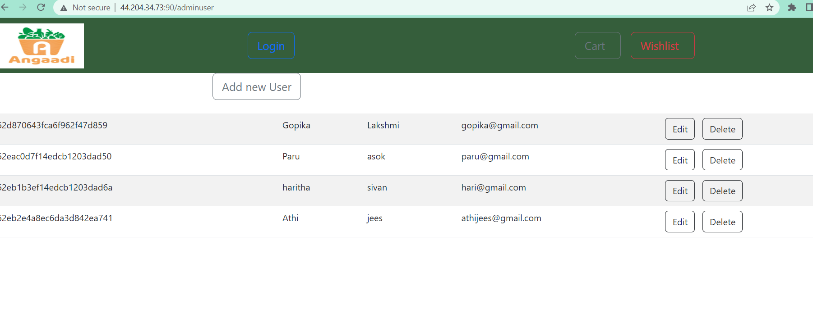

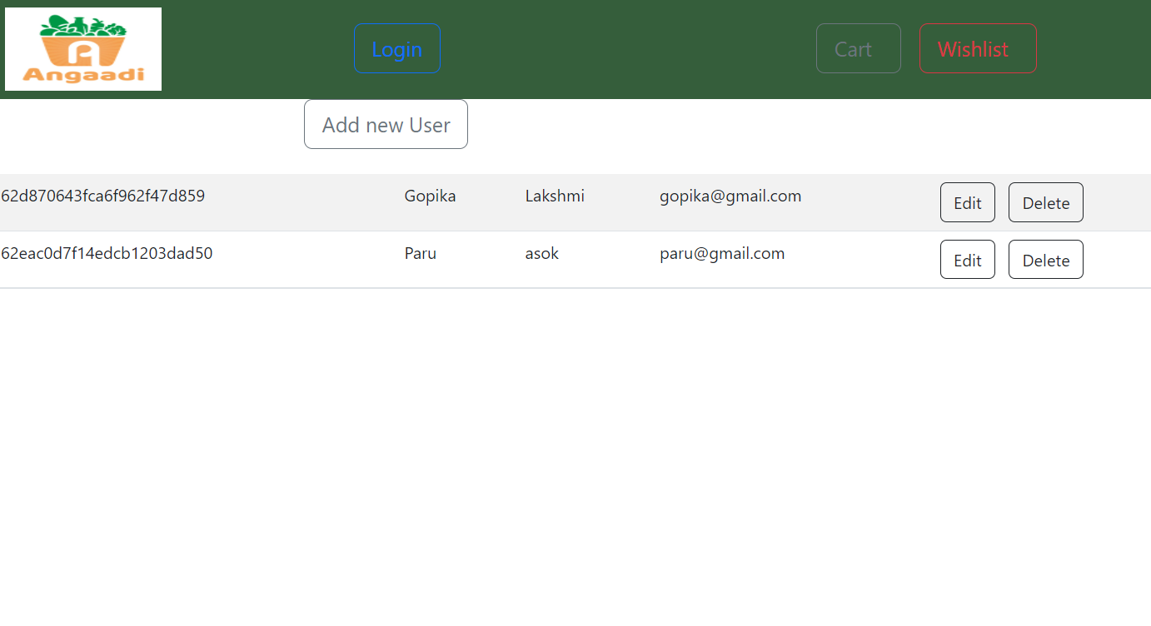

The user is removed

**Grocery Settings**

1.select grocery settings

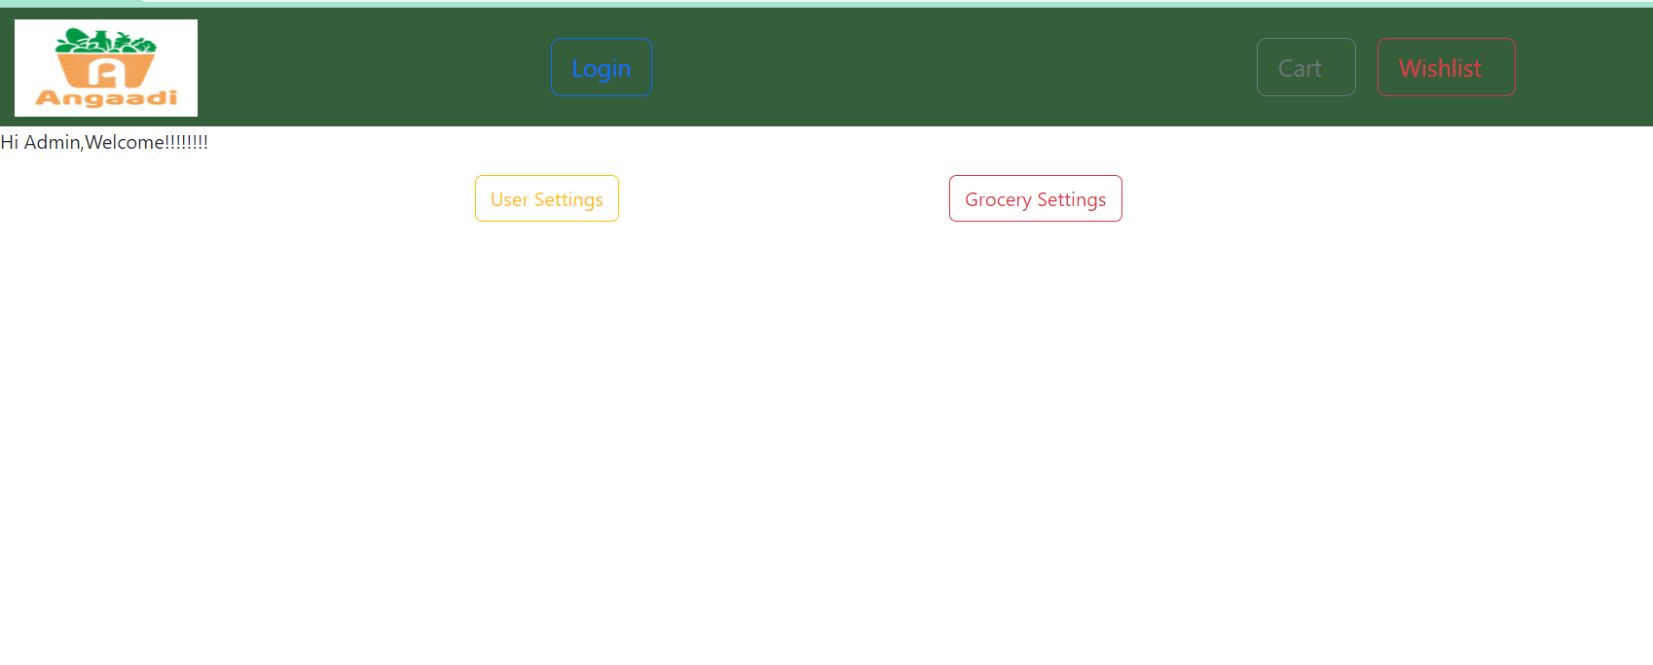

**2.**admin grocery settings page will be open

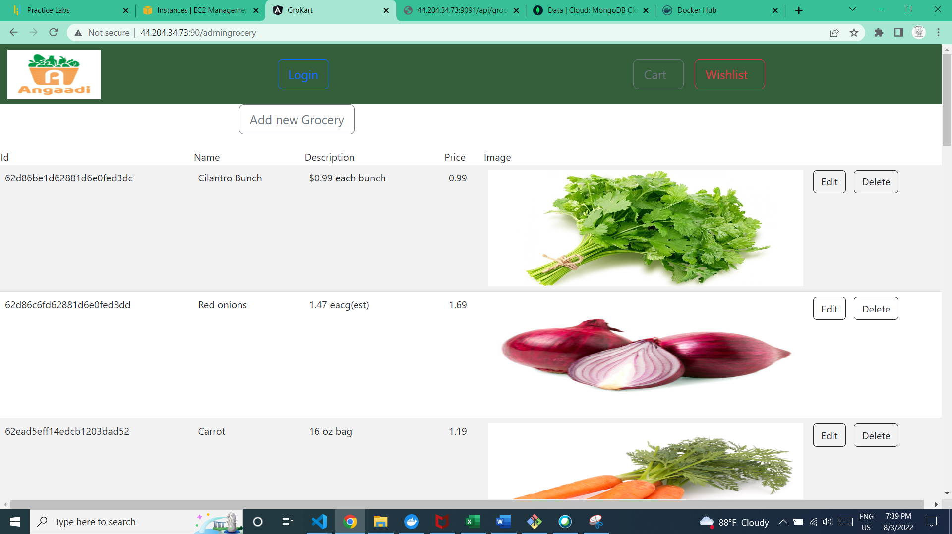

**Add new grocery**

1.click add new grocery button

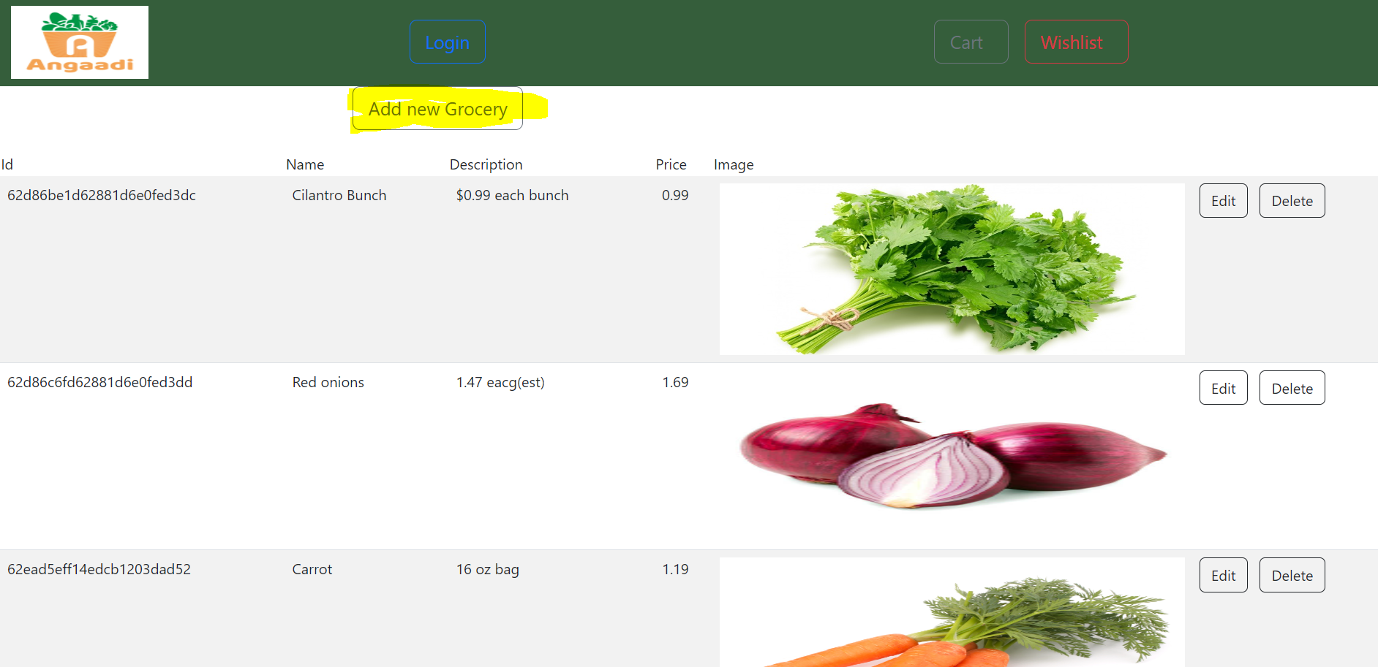

2.fill all the field,all the field s are manadatory except description

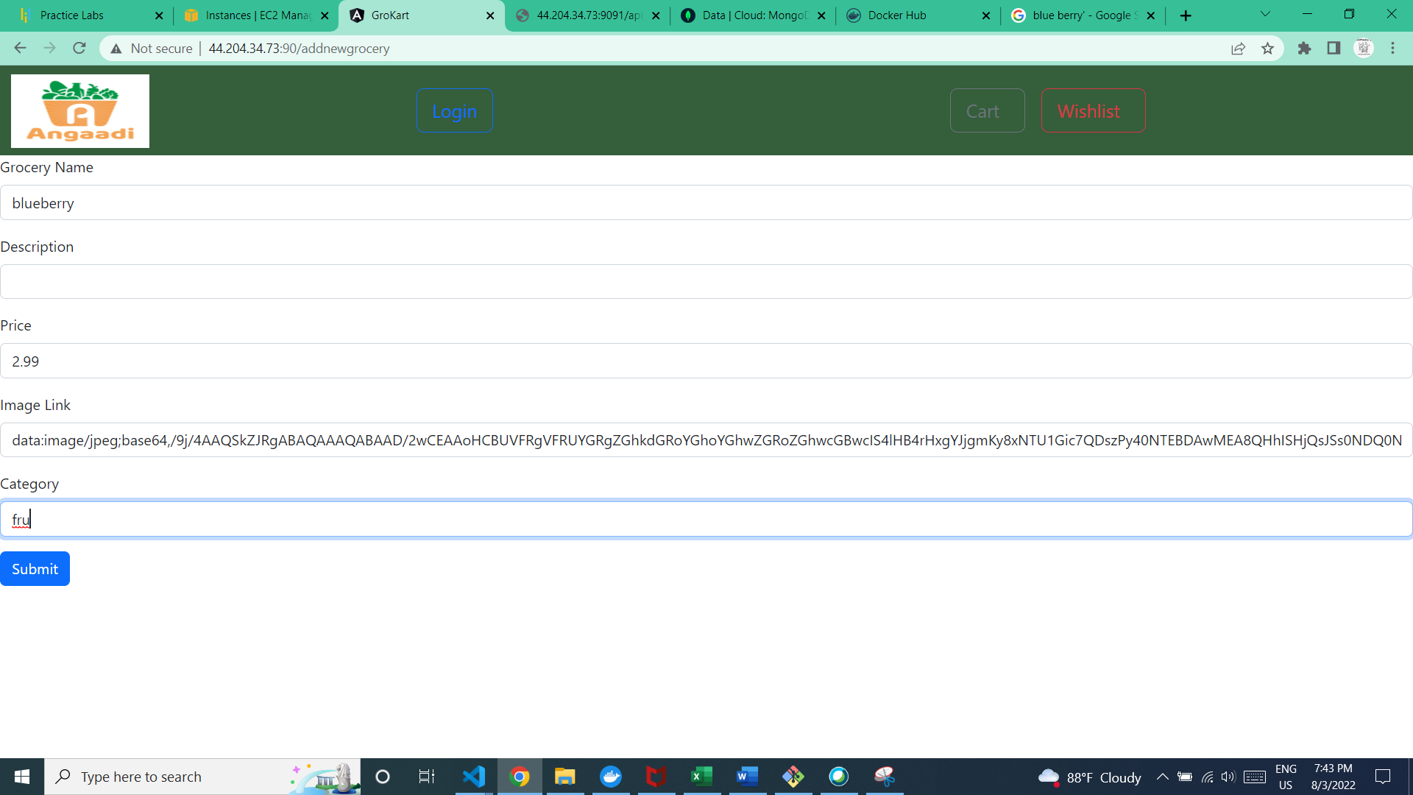

**The category should be veg for vegetables,fru for fruits and D for Diary products**

3.The new grocery is added

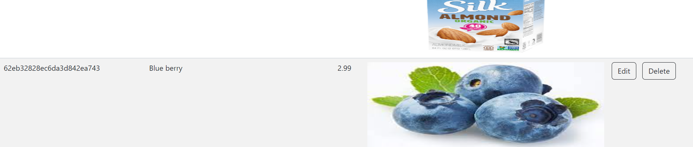

**Edit Grocery**

1.Click on the edit button

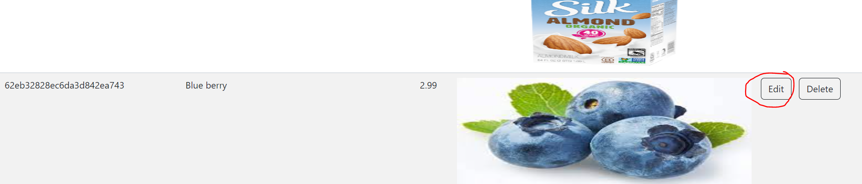

2.edit the details

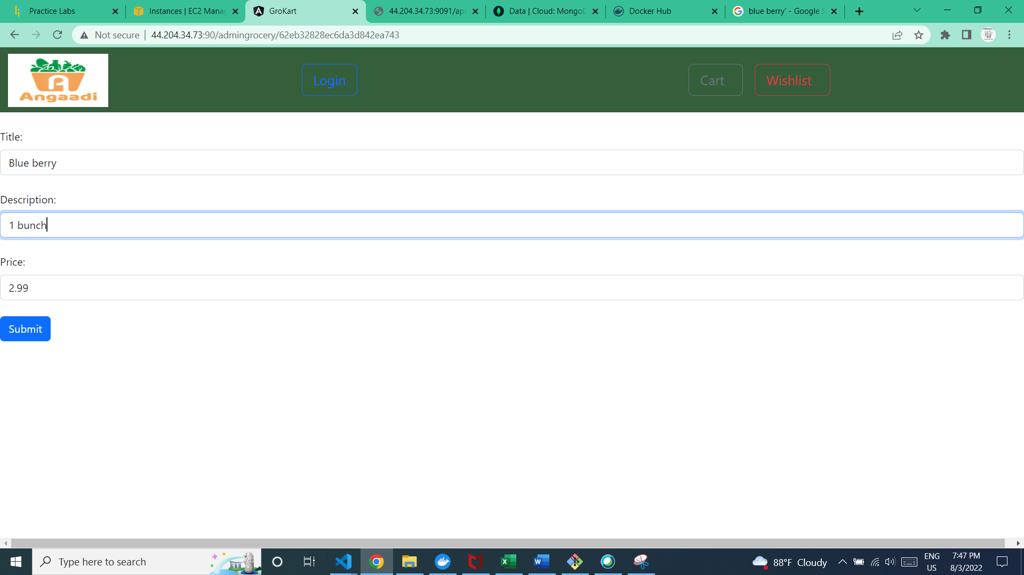

3.updated the details

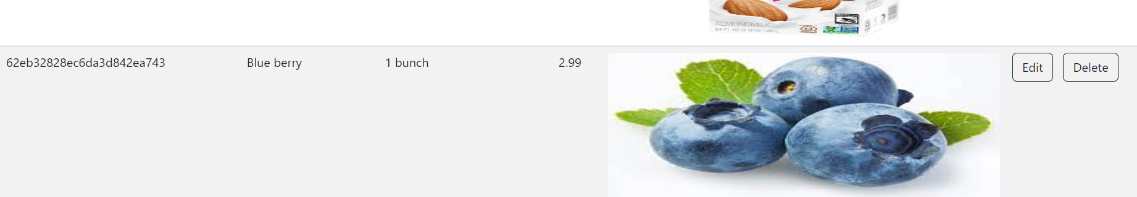

**Delete Grocery**

1.click on the delete button

